

**A Comprehensive Historical Review of River Bank Erosion Hazards and Disaster Impacts in Bangladesh 1971-2020**

This paper has been prepared and submitted for the partial fulfillment of the requirement for the ‘Introduction to Geography’ course

Report on River Bank Erosion Hazard & Disaster Impacts in Bangladesh

|  |  |  |
| --- | --- | --- |
| **Name** | **ID** | **Contribution part** |
| Md Amjad Hossen | 1632698042 | 1.2 & 1.3 |
| Rahnoom Bin Abedin | 1711630630 | 1.0 & 1.1 |
| Faiyaz Rahman | 1712905030 | 3.1 & 3.2 |
| Sharina Jamal (Leader) | 1721496030 | 3.3, 5.0 & whole report compilation |
| Wasimul Islam (Co-Leader) | 1721694042 | 2.1, 2.2 & 2.3 |
| Nashfin Nawar | 1721842630 | 1.4 & 1.5 |
| Taoseef Anzoom Naazil | 1721908630 | 4.1, 4.2 & 4.3 |

**SUBMITTED TO  
PROFESSOR Dr. Md. Nazrul Islam**Professor,  
Department of Geography and EnvironmentalNorth South University **SUBMITTED BY  
Group Hokkaido**

Course: Env203/Geo205|  
Section: 7  
Fall 2020  
10 January, 2021

**Acknowledgement**

Firstly, we ‘d like to remember the Almighty Allah for allowing us to finish this report on time and efficaciously. We might want to offer our obligation of thanks to our respectable faculty Dr. Nazrul Islam, Associate Professor, Department Environmental Science and The board, North South University, for his steady motivation, valuable analysis, liberal direction, and profound interest in this investigation. Without his legitimate rule, the investigation probably won't be conceivable appropriately to finish in due time. We 'd like to express our genuine thanks to the Chairman of the Department of Environmental Science and Management. We 'd additionally like to thank such countless astonishing analysts everywhere on the world who are right now dealing with this very issue. For this exploration we couldn't do any hands on work. So the total of our work relied upon these astonishing investigates, diaries, periodicals and examination papers that were distributed by such countless astonishing specialists. Referencing every one of them here is practically incomprehensible. We have recognized them through innumerable references in everywhere on our fundamental assortment of report. At last, we might want to thank our dear sir Dr. Md. Nazrul Islam by and by for giving us the occasion to do this examination which advanced we all with our newly discovered information.

**Table of Contents**

**Abstract 06**

**Chapter 01: Introduction 07**

**1.0 Introduction 08**

**I.1 Statement of the Problem 09-10**

**1.2 Literature Review 11-17**

**1.3 Significant of the Study 18**

**1.4 Limitations of the Study 19**

**1.5 Organization of the Study 20**

**Chapter-02: Study site and Methods 21**

**2.1 Study Area and Issues 22-24**

**2.2 Data sources of the Study 25-26**

**2.3 Methodology of Data Collection and Analysis 26-31**

**Chapter-03: Scenarios of the Problem in Global and Regional Contexts 32**

**3.1 Case base Scenarios or Condition 33-39**

**3.2 Compare with other Countries and Global Perspective 40-43**

**3.3 Future Scenarios and Our concern 44-51**

**Chapter-04: Results and Discussion 52-55**

**4.1 Results 55-59**

**4.2 Discussion 59-69**

**4.3 Recommendation 69-70**

**Chapter-05: Conclusion 71**

**5.1 Conclusion 72**

**References 73-76**

**List of Figures**

**Figure 1.2.6:** Conceptual frame work…………………………………….................................**17**  
**Figure 2.1.1.1:** Map of Padma River…………………………………………………………..**23**  
**Figure 2.1.1.2:** Naria Upazilla, Shariatpur Health Complex Collapsing in Padma…………....**23**  
**Table 2.3.2.1.1:** Tabular Representation of the Land satellite images utilized in the study…...**27**  
**Table 2.3.2.1:** Tabular Representation of the Erosion-Accretion Net along the Padma River...**28**  
**Figure 2.3.2.1:** Graphical Representation of River Bank Changes of the Padma River, Due to Erosion and Accretion for 1975-2015………………………………………………………......**29**  
**Figure 2.3.2.2:** Map showing Padma River Blockage by Islands or Char Land……………….**30**  
**Figure 2.3.2.3:** Graphical Representation of the Total Water Surface During 1975-2015……..**30**  
**Figure 2.3.2.4:** The Line Diagram Indicates the Direction and Rate of Shifting of Bank Line..**.31**  
**Table 2.3.2.5:**  Tabular Representation of the Bankline Shifting due to Erosion and Accretion 1975–2015………………………………………………………………………………………..**31**  
**Table 3.1.1:** Tabular Representation of the River Bank erosion in Padma River during the   
period 1973-2017 in different districts ……………………………………………………….....**35**  
**Figure 3.2.1.1:** Graphical Representation of The link between the watercourse channel  
 migration rate and also the drainage basin of the watercourse…………………………………**40**  
**Figure 3.2.1.2:** Mississippi river………………………………………………………………..**41**  
**Figure 3.2.2:** Yellow River……………………………………………………………………..**42**  
**Figure 3.2.3:** Eroded earth cliffs on northern bank of River Nile seen from launch Murchison Falls National Park Uganda East Africa…………………………………………………………**43**  
**Figure 3.3.1.1:** Predicted riverbank erosion along the Jamuna, Ganges and Padma Rivers……**44**  
**Table 3.3.1.2: Erosion Prediction for 2020**……………………………………………………**45**  
**Figure 3.3.1.3:** Experts predicted River Erosion in Northwest for the year 2020………………**45**  
**Figure 3.3.1.4:** Riverbank Erosion Prone Areas for 2020………………………………………**46**  
**Figure 3.3.4.1:** Local authorities have placed sandbags to reinforce riverbanks near Kedarpur village…………………………………………………………………………………………….**49  
Figure 3.3.4.2:** A lad watches river defense work nearby Kedarpur village. Experts are reinforcing the banks with sandbags and concrete constructions………………………………..**49**  
**Figure 3.3.4.3:** Construction in process to prevent Padma Riverbank Erosion…………………**50**  
**Figure 4.0:** The disaster situation occurs in char areas and other Upazilla…………………….**55**  
**Table 4.1:** Tabular Representation of River Bank erosion in Bhapal Upazilla…………….......**56**  
**Figure 4.1.2:** Graphical Representation of the Distribution of the respondents according to  
 their origin displacement……………………………………………………………………….**56**  
**Figure 4.1.3:** Graphical Representation of the Distribution of respondents according to their reason for migration………………………………………………………………………….....**57**  
**Figure 4.1.4:** Graphical Representation of the Distribution of the respondents according to   
their pattern of displacement……………………………………………………………………**57**  
**Figure 4.1.5:** Graphical Representation of the Distribution of the Respondents to their Pattern   
of Homestead Shifting……………………………………………………………………….....**58**  
**Figure 4.1.7:** Graphical Representation of Distribution of Respondents According to   
Ownership of Newly Emerging Land…………………………………………………………..**59**  
**Table 4.1.8:** Tabular Representation of the Occupational Structure of the Respondents   
of the Study Area……………………………………………………………………………….**59**  
**Figure 4.2.1.1:** Trend of River Bank Erosion from 1973-2006………………………………..**60**  
**Figure 4.2.1.2:** Graphical Presentation of Erosion since 2000-2009…………………………..**60**  
**Figure 4.2.2.1:** Gorai at Kumarkhali point (At present)……………………………………….**61**  
**Figure 4.2.2.2:** Bank line of various study area at Kumarkhali point…………………………**62**  
**Table 4.2.3.1.1:** Tabular Representation of the Age of the Respondent………………………**62**  
**Table 4.2.3.1.2:** Tabular Representation of the Martial Status of the Respondent……………**63**  
**Table 4.2.3.2:** Tabular Representation of the Education level of Respondent………………...**63**  
**Table 4.2.4.1:** Tabular Representation of the Gorai Riverbank Erosion Experience (Source   
field survey 2014)………………………………………………………………………………**64**  
**Table 4.2.4.2:** Tabular Representation of the Victims of Gorai RBE. (Source field Survey 2014)……………………………………………………………………………………………..**64**  
**Table 4.2.5:** Tabular Representation of the Losses of the Livelihood during 1950-1999……...**65**  
**Table 4.2.6.2:** Tabular Representation of the Amount of Cultivate Lands Loss……………….**66**  
**Table 4.2.7.1:** Tabular Representation of the Miserable status of Gorai Victims……………...**68**  
**Figure 4.2.7.2:** Shows the miserable scenario of Gorai Bank Erosion……………………….....**.68**

**Abstract**

The paper gives a review of Bangladesh populaces evacuated by river bank erosion. The investigation portrays the actual ecological states of the examination region with a unique consideration regarding regular catastrophes of the area. It centers the socio-segment profile of the survivors of the examination region. Caused riverbank erosion a significant extent of the casualties is constrained to leave the first residence plot and take cover by the street side bank, neighbors land and relative land. The medical issue of the casualties is low. Since the normal natural circumstances, the monetary emergency and destitution have been discovered to be identified with catastrophic event like riverbank erosions, so in this decade of climate the strategy producers and scientist at the public level should know about the greatness of the ecological states of the riverbank disintegration casualties. Indeed, that, caused riverbank disintegration consistently joblessness, landless and neediness are expanding which is capable to nationwide temperamental condition. Even this research paper gives an overview of the impact in the recent year, 2020 caused by river bank erosion and prediction for the near future river bank erosion in Bangladesh. This study aims to set up a comprehensive approach to the Vulnerability and Impact Assessment (VIA) of river erosion and to suggest Ecosystem-based Adaptation (EbA) practices.

**Chapter 1: Introduction**

1. **Introduction**

Bangladesh is one of the world's largest deltas. With a generic hilly region, restricted high ground, and a vast area of plain land washed by river water, entire Bangladesh is created. About 310 rivers and tributaries have made this nation a land of rivers. But in recent years, riverbank erosion seems to have been a frequent natural disaster in Bangladesh **(Siddique et al., 2014; RIC, 2008).** Erosion of the riverbank is a common concern for many countries in all parts of the world, although erosion can differ in nature and effect. Riverbank erosion is also an immense concern for our country's socio-economic market. Irregular floods and sudden movements in riverbanks seriously conflict with human settlement and operations. As they repeatedly change their course, rivers are complex structures. Erosion and accrual in its natural phase are natural. Riverbank erosion happens both naturally and through human intervention. Around 10,000 hectares of land being destroyed by erosion every year, according to the National Water Management Plan-2001 **(Government of Bangladesh, 2010).**

Erosion casualties are typically moderate and progressive. In coming years, yet they will be quite problematic than other unexpected and catastrophic calamities **(ibid.).** This condition is much more troubling given that about one million people are affected by the loss of river banks every year **(Working Group on Equity and Justice, 2007 cited in IOM, 2009).** One of the most corrosive challenges in the world at present is environmental migrants. No other catastrophe is as devastating as the riverbank erosion as people migrating face many imminent problems at varying levels of relocation. In terms of survival, migration impoverished them and forced them to lead a floating life. According to the ISPAN report, 728,439 people were displaced from their initial homes by riverbank erosion between 1981-1993. The estimated migrations were at 63,722 per year. Four million people in Bangladesh are forced to live suspended lives **(Islam et al, 2011).** Thus, erosion of the riverbank is one of Bangladesh's most crucial calamities every year.

**1.2 Statement of the Problem**

Bangladesh is the world's largest delta, created by the river system of the Ganges, the Brahmaputra, and the Meghna (GBM). This delta is characterized by flat terrain interlaced with a complex web of about 700 rivers, canals, and streams, about 22,155 km in total length (BBS 1979, 1984), bringing downstream an immense volume of sediment-laden water. Over 92% of the annual runoff generated in the GBM region flows through Bangladesh, which is only around 7% of the total area of the catchment **(Ahmad, 2000).** A high volume of water is therefore flowing through Bangladesh. It's projected that a total of 870 million acre-feet (MAF) of water flows from India into the nation each year. With evaporation, evapotranspiration, and deep percolation losses likely to account for around 120MAF, the amount of rainfall within this country is estimated at 203MAF. This suggests that about 953MAF flows out to sea, 914MAF flows through the Ganges-Brahmaputra delta (in Bangladesh) also 39 MAF flows through the Chittagong sub-region and Feni district rivers **(Rashid 1991).**

**1.2.1 The Gorai River:**

The **Gorai River** is a distributary of the **Ganges.** For Bangladesh, it is a significant artery, as it is the source of fresh water for the south-west of the country **(Addams, 1919).** At the point of **Chapai Nawabganj,** the Ganges entered Bangladesh and took on the form **‘The Padma’**. The **Gorai** takes off from the Padma at **Talbari Kushtia.** After nearly 190 kilometers, the river flows into the **Bay of Bengal.** The **Gorai**was probably first established between the fourteenth and fifteenth centuries, according to DHV-Haskoning (2000). The shape of this river changed because of changes in the shape of the **Ganges (Clijncke, 2001).**

**1.2.2 Ganga-Kabodak Irrigation Scheme**

The Irrigation Scheme **Ganga-Kabodak (GK)** was carried out in 1954-55 **(Banglapedia, 2003).** The two **Gorai**distributors, the **Dakua**and the **Kaliganga**were stopped from making canals at that time. The **Gorai's** water flow was disrupted at the time, and so is the current. Its flow was once again slowed when the **Farakka Barrage** was built in 1975. According to Raalte, “From that time

discharge of the river started decreasing rapidly and annual sedimentation rate was significantly increasing” (2013).

As a result, the river lost its depth day by day and the erosion of the bank at different points of the **Gorai** river worsened. People have lost their homesteads, cultivable lands, due to the **Gorai**riverbank erosion at the **Kumarkhali**point from **Baruria** to **Agrakunda.** Two major educational institutes and even the roads of **Kumarkhali-Baruria** and **Kumarkhali-Tebaria-Agrakunda**have been damaged.

The channels have been swinging between the major valley walls over the last 200 years or so. Extensive bank breaches, bank erosion, and bank line changes are frequent during the monsoon. The incremental migration or transition of large river channels in Bangladesh varies from 60 m to 1,600 m each year. Approximately 2,400 km of the bank line undergo significant erosion in a single year. Not only does the erratic changing behavior of the rivers and their invasions impact the agricultural floodplain population, but also the hub of economic development and infrastructure.

**Literature Review Topics Discussed**

1.2.1 Erosion

1.2.2 Riverbank erosion

1.2.3 Impacts of Riverbank erosion

1.2.4 Socio-Economic Impact

1.2.4.1 Socio-Economic Impact of Riverbank erosion

1.2.4.1.1 Demographic Change

1.2.4.1.2 Resettlement Issue

1.2.4.1.3 Income Erosion

1.2.4.1.4 Degradation of the Standard of Life

1.2.5 Influence of Bad Governance

1.2.6 Conceptual Framework

**1.2 Literature Review**

**1.2.1 Erosion**

The word erosion has come from the Latin term “rodere” (NSW DPI Website). It means gradually reduce’, the same origin that gives us the word ‘rodent’. Simply erosion means soil removal from the earth’s surface. According to Dictionary.com, it is process by which the surface of the earth is worn away by various agents like water, winds, waves etc.

From different point of views, the conception of erosion may vary. From biological point of view, Erosion is “the changing of a surface by mechanical action, friction, thermal expansion contraction, or impact (Wiktionary Website).” The Connotation sounds a little bit different in agriculture. In agriculture, soil erosion refers to the wearing a way of a field's topsoil by the natural physical forces of water and wind or through forces associated with farming activities such as tillage (Ritter, 2012).

In Geology “erosion is the process of the movement of loosened or weathered materials from one place to another, and occurs due to the agents of erosion -wind, moving water, moving ice, and gravity (Answers.com Website).” Though erosion is a natural process, excessive erosion causes desertification, decreases in agricultural productivity due to land degradation, sedimentation of waterways, and ecological collapse.

**1.2.2 Riverbank Erosion**

Riverbank erosion is a “geo-morphological process of alluvial floodplain rivers”. Simply it is defined as the process of wearing of the banks of a stream river. It is because of bank adjustment, bank trampling, and changes in bed elevation and topography in reaction to modified flow conditions or bank resistance. Bank erosion is a natural process; without it rivers would not meander and change occurs (Wikipedia Website). Severe riverbank erosion causes heavy displacements along the bank line of the rivers and impacts result in the socio-economic change.

**1.2.3 Impacts of Riverbank Erosion**

Impacts of riverbank erosion on people, society, culture, environment and ecology are very high. Increased erosion leads to decreased water quality that negatively impacts instream health and lead to the loss of native species. Plants growing on the bank reinforce the soil and provides over hanging trees, bushes, grasses and reeds that provide shelter for fish and other aquatic organisms. Tree roots growing along the bank also provide habitat for fish and other animals. When riparian vegetation is removed habitat for aquatic animals’ declines. Erosion can produce wider, shallower streams with uniformly sandy beds- unsuitable habitat for many aquatic organisms. When sediment settles to the bottom it covers the living space for many bottom-dwelling plants and animals. Sediment can block sunlight for aquatic plants, can clog the gills of fish, and reduces the amount of dissolved oxygen in the water, which is necessary for aquatic organisms to survive.

Many riparian areas are valued as sites of cultural and spiritual significance. Accelerated erosion of riverbanks can directly undermine cultural artifacts such as wharfs, bridges, buildings and monuments. Erosion of riverbanks can negatively impact on the cultural links people have to the special parts of the landscape. Riverbank erosion plays a major role in socio-economic changes too. The displaced people experience substantial socio-economic impoverishment and marginalization as a result of compelled-displacement from the original residence (Islam et al, 2011). Due to erosion displaces suffer from poverty, income erosion, occupation change, displacement, social destruction, degradation of quality of life and many others.

**1.2.4 Socio-Economic Impact**

The word ‘socio-economic’ is used to describe something that relates to or is concerned with the interaction of social and economic factors. It is basically, income and social position that is used to measure the status of a family or an individual in a community (Ask.com). Socio-economic factors include income, education, occupation, and involvement in the community.

According to Mary Edwards (2000) the indicators usually used to measure the potential socio-economic impacts are-

* Changes in community demographics
* Demand for housing
* Changes in employment and income levels
* Changes in the standard of life of the community

Demography: Demographic impacts include the density and distribution of the people and any change in the composition of the population (e.g. age, gender, ethnicity, income, occupational characteristics, educational level, or health status).

Housing: It is strongly related to a community’s land use, social bond and security. Displacements due to disaster break the community’s land use pattern, social bond and security.

Employment: Development directly influences changes in employment and income opportunities in communities. Similarly, disaster like riverbank erosion that causes displacements etc. also directly influences the employment and income of the people of the community.

Standard of life of the community:When the people are compelled to compromise with their basic and fundamental needs the standard of life deteriorates. When people lose their income sources or when their incomes erode usually standard of life falls.

**1.2.4.1 Socio-Economic Impacts of Riverbank Erosion**

Riverbank erosion has terrible socio-economic impacts on people in our country. Very often it creates adverse effects on people damaging standing crops and infrastructure, destroying settlements and disrupting communications. The degree of economic loss and sufferings of people has increased in recent years and the total monetary loss is estimated to be approximately USD 500 million a year (Hasan, 2011).

The effect is enormous and the loss is quite impossible to regain.

**1.2.4.1.1 Demographic Change**

Riverbank erosion forced people frequently to move to other places for shelter. Thus they get separated from their well-known society. They lose their social bond. Also their family ties breakdown. The joint family system is one of the most ancient traditions of our country. The joint family culture also gets hampered due to erosion.

**1.2.4.1.2 Resettlement Issue**

Due to riverbank erosion many people lose their homestead and houses. When erosion is slow they can shift their household materials. But when erosion takes place rapidly and comes towards their houses, they all together dismantle their houses themselves pursuing to shift household materials. But all of them do not get enough time to take house materials. Many of them become victims of such incidents several times. Smaller owners of lands suffer a lot. After getting uprooted from the living place searching for homestead land becomes the main priority and a few of them can manage to become landowner. Sometimes they become destitute and live in Khasland.

**1.2.4.1.3 Income Erosion**

Any kind of displacement has direct impact on regular sources of income and income generating activities of the forced migrant households. Loss of income compelled them to live a sub-standard life and they could not continue their way of living even parallel to the way before displacement. They face difficulties to find new sources of income in new settlement areas. Riverbank erosion forced migrant take shelter in distant places or migrate to urban areas. The landless and jobless heads of the households under financial duress often desert their families. Left alone, women of those households has to struggle hard to maintain their family.

**Loss of cultivable:** Due to riverbank erosion many farmers become poor overnight. As agriculture is the main livelihood for maximum people, losing cultivable lands economically they become vulnerable. Finding no other alternatives maximum farmers become day- laborer. Sometimes they fail to cope with changed situation.

**Loss of kitchen garden/home yard land**: Trees and plants sometimes become the alternative source of money to the rural people. Mango jackfruit, Papaya trees are available in many houses. They eat these fruits and sometimes earn money selling the fruits in local market. The trees also provide wood. In rural areas of Bangladesh bamboo trees are very common in almost every house. The bamboo not only meets their domestic needs but also helps to earn some money. But due to erosion the victims lose all the scopes.

**1.2.4.1.4 Degradation in Quality of Life**

River erosion induced forced migrants very often go through heavy social change. The impacts on the migrants may be positive or negative. But in most of the cases the impacts are negative. Due to riverbank erosion the victims lose their homesteads, cultivable lands, crops, livestock, plants and trees, business centers etc. Losing all these they suffer from income erosion and are compelled to lead sub-standard lives. They cannot spend more money for food, heath care, education and other necessary things of life.

**1.2.5 Influence of Bad Governance**

For proper implementation of any development policy, participation of the people, who are directly or indirectly related to this, is badly important. People who would enjoy the benefit of this development should own it. Otherwise it may not serve the purpose effectively. But like most of the developing countries in our country the participation of people in development is not well accepted. Development work is very often not need based rather political will and personal interest-driven. So it fails to ensure transparency and accountability. It is because of lack of good governance. In the following context the limitations in terms of governance issue are very often observed in our country. Interest driven and political motivated policy: Because of the lack of commitment from the political leaders and policy makers very often interest driven and political motivated projects are taken.

People’s participation: In our country development is a top-down approach. People have rarely any participation. As a result, they do not own development and frequently it fails to serve the purpose. As a result, sufferings of the people remains as it are and development is very often wastage of national assets. Proper and timely policy: Government takes various measures to control erosion. Unplanned, untimely and political motive-driven initiatives have less positive impacts on socio-economic vulnerabilities. So sufferings and degradation of standard of life of the people continue.

**1.2.6 Conceptual framework**

Due to riverbank erosion forced migrants go through heavy loses of wealth. As a result, they become asset less and subsequently, poorer than before. This loses lead to income erosion of the victims. They are compelled to lead a painful and measurable life. Their standard of life falls and vulnerability of life increases. Government takes various initiatives to control erosion. Local people get less scope to participate in decision making, and actually it is imposed from the top. Policy taken is very often less effective. As a result, development does not fulfill the purpose and results into wastage of public wealth. It does not help in increasing the standard of life of the community.

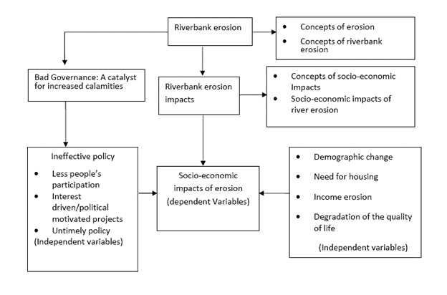

**Figure 1.2.6: Conceptual frame work**

**1.3 Significant of the study**

Bangladesh is suffering from acquit riverbank erosion. It has been estimated that between 2,000 to 3,000 kilometers of river-bank line experience major erosion annually (Islam and Islam, 1985). Erosion compels millions of people to be displaced from their place of origin.

Riverbank erosion forced migrants face many unavoidable problems in different times of displacement, i.e. before displacement, during shifting household materials and family members and after displacement at new settlement area. Migrants lives in an area for long time - from generation to generation. Due to riverbank erosion, they are forced to migrate from their places of origin to other places. Displacement due to riverbank erosion marginalizes them in respect of livelihood patterns and psycho-physical troubles (Islam et al, 2011). The troubles, problems and losses the displacers face are losses of land and changes in land holding capacity, changes in economic activities and loss of income, loss of house structure, loss of crops, loss of security and so on (Islam et al,2011).

This study aims to set up a comprehensive approach to the Vulnerability and Impact Assessment (VIA) of river erosion and to suggest Ecosystem-based Adaptation (EbA) practices. Based on the analysis of vulnerability using the Driver-Pressure-State-Impact-Response (DPSIR) framework, this paper discusses some of the significant climatic (rainfall pattern, temperature, seasonal drift, cold wave and heat wave) and non-climatic (river erosion, repetitive death of field crops and agrochemicals) forces in Bangladesh. Both primary (Key Informants Interview, Household Survey, and Focus Group Discussion) and secondary (climatic, literature review) data have been used in revealing the scenario of climatic stress. This study found that river erosion, the increase of temperature and the late arrival of monsoon rain, excessive monsoon rainfall, high use of agrochemicals, and flow alterations are major drivers in the riverine ecosystem. These drivers are creating pressures on agricultural land, soil fertility, water availability and livelihood patterns of affected communities. Hence, floating bed cultivation, integrated pest management, use of cover crops, reforestation, the introduction of an agro-weather forecasting system, and a new variety of flood tolerant species have been suggested as potential Ecosystem-based Adaptation to cope with river bank erosion and to increase the capacity of the affected ecosystem.

**1.4 The Limitations of the Study**

This project is an academic one with limited time and a small study area. The study needed more sample surveys or case studies from different parts of Bangladesh to understand the exact condition in detail. So there remains some gap to reach the proper solution.

* **Time constraint:** The time provided for the project is limited. Only two months is not sufficient time to conduct quality research. Time for collecting data is not enough. Also, the qualitative study requires more time to analyze the data collected. At the same time, extra time is essential to design the research in light of new developments and insights.
* **Selected study area:** The study area was small and selective. There may be some variation as the sample has taken from a particular geographical location for time and budget constraints.
* **Non-availability of data and documents:** For the topic, we needed to discuss with different people from different areas especially the areas where riverbank erosion has a huge impact. As we couldn’t visit the areas physically, we had to depend on the news, papers, research papers, and documentaries already published. There weren’t enough resources and data we needed. So it was a little bit difficult to cover the topic with fewer data. During the time of making our project, we couldn’t do any practical experiment and analysis, due to a lack of time and enough funds. It’s also one of the main limitations.
* **Determination of various losses:** Losses for homesteads, cultivable lands, and kitchen garden/home yard land are calculated based on the value (approximately) given by the respondents on the internet. Remarkable variation may be observable. But it does not influence the findings broadly.
* **Determination of Sample size:**Due to the reason of COVID-19, the number of affected households comes from the information on different websites that has been used in determining the sample size. According to that, half of the total households of Bangladesh have been affected.

**1.5 Organization of the Study**

Our study area focuses on a comprehensive historical review of riverbank erosion hazards and disaster impacts in Bangladesh from 1971-2020. To explain that, first we need to know what the reasons behind these riverbank erosions are and what are the future scenarios and our concerns should be. Most importantly, how can we prevent or decrease the hazards and disasters in the future. Here, the organization of our study contains five chapters.

* The first chapter discusses the initial idea of riverbank erosion. The impacts of hazards and disasters that Bangladesh was facing from 1971-2020 and the people and household projects who were pioneering simple, effective life-saving solution to the losses for homesteads, cultivable lands, and kitchen garden/home yard land.
* The second chapter focuses on the historical background of riverbank erosion. And the methodology of our data collection system. In this part, we briefly discussed the hazards and disasters described in the first chapter and added many facts. It also focuses on the impacts on which we are basing our study.
* Now, the third chapter focuses on a broader spectrum. It describes the historical review of riverbank erosion hazards and disaster impacts in Bangladesh from 1971-2020 with case base scenarios. It also gives us a glimpse of our concern by fully predicting the future.
* The fourth chapter talks about the whole studies that have been done so far and demonstrates a general result. It also suggested some recommendations to prevent or decrease the impacts of hazards and disasters.
* The fifth chapter concludes the report and gives a summary of the review. It includes everything from the first to the fourth chapter. Facts are not regarded as the concentration here as it is more focused on the worded summary.

**Chapter 2: Study Site and Methods**

**2.1 Study Areas and Issues**

This chapter contains the research methodology of the study. The chapter deals with various steps- study area selection, sample design and procedure, sample size determination, data processing, analysis- for completion of the research. Actually, it focuses on the methodologies followed for conducting the research work from selection of the study area to analysis of the final report. For the present work data collection methods and techniques were mainly household questionnaire survey and informal discussion with the aged people who have experienced erosion.

**2.1.1 Selection of Study Area**

This study concentrates the Padma River which is located in Bangladesh, 120 km long and its width varies from 4 to 8 km (Chowdhury 2003). The study area (Fig. 2.1.1.1) embraced the confluence points of the Padma-Jamuna at Goalanda, Rajbari and the Padma-Meghna at Matlab, Chandpur. The study area which lies between the latitude 23°50′–23°13′N and longitude 49°43′–90°39′E, and it passes through the Chandpur, Dhaka, Faridpur, Madaripur, Manikganj, Munshiganj, Rajbari and Shariatpur districts. The Padma River is characterized by Ganges river system. The annual average discharge is 35,000 m3 s−1 and the average width of the river is 10.3 km (CEGIS 2010). The velocity ranging from 4–5 m s−1, with depth varying from 20 m to 21 m and annual silt load of 492 t km−2. The average gradient from Goalandaghat to Chandpur is 1:37,700 or 0.000027 degree for a distance of 120 km (ADB 2010). The characteristics of the sediment of the northeast bank is alkaline soil and the southwest bank is peat (CEGIS 2010). The Padma has high water flow in the monsoon and much less in the dry season, erosion and deposition of the Padma riverbank are influenced by the unstable water flow during the monsoon and dry season, and by yearly flood (Islam 2010). The mean annual rainfall is 2,000 mm of which about 70% occurs during the monsoon season; the average temperature is 25.5°C to 26°C (Hassan and Akhtaruzzaman 2010).

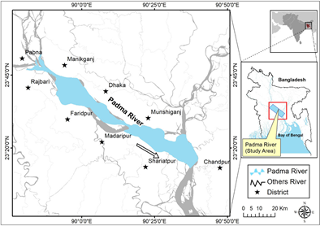

**Figure 2.1.1.1: Map of Padma River**

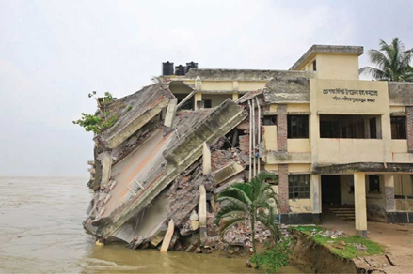

**Figure 2.1.1.2: Naria Upazilla, Shariatpur Health Complex Collapsing in Padma**

**2.1.2 Issues with Selected Area**

People there are on the edge as the river has changed its course and has been gobbling up village after village, making even the well-off people penniless overnight. Impacts of riverbank erosion are multifarious - social, economic, health, education and sometimes political in nature. The first and foremost impact is social i.e., people become homeless due to land erosion that compels them to migrate. After forced migration, they suffer from economic crisis i.e., loss of occupation and loss of property. Sometimes, they indulge in criminal activities.

According to hydrology expert Dr Ainun Nishat, "The Padma flows on her own whims, you cannot understand Padma with mathematics or science. River erosion is a natural course. The erosion may continue for two years in the location. In order to take preventive measures, we have to understand the scale of Padma. Whatever that may work to prevent erosion in the Gorai, Madhumati, or other small rivers won't work in case of Padma". (Sobhan, 2018)

According to a report published in August this year by online publishing outlet of NASA, hundreds of hectares of land, sometimes even thousands of hectares of land, fall into the Padma River every year through erosion. Since 1967, more than 66,000 hectares (256 square miles) of land has been lost - roughly the area of Chicago.

Water management experts wonder whether the under-construction Padma Bridge, has any link with the change of course or behavior of the Padma River. The river stabilization plan, currently being prepared, contains some ideas about what to do in this area, but is cautious enough as it recognizes that the impact of the Padma bridge river training work is not fully quantifiable.

The Centre for Environmental and Geographic Information Services (CEGIS), which carried out the Padma bridge study and was involved in the formulation of the river stabilization plan, is conducting annual erosion prediction of the Padma River. The CEGIS is currently updating the morphology for the Padma Bridge. It is essential to protect the Padma riverbanks and prevent further erosion. The Sustainable Development Goals (SDGs) acknowledge the direct relevance of floods and erosion to poverty and suggests flood control and riverbank protection measures amongst others. Due attention should be given to help save people vulnerable to river erosion in a sustainable manner.

**2.2 Data Sources of the Study**

Bangladesh is one of the riverine countries in the world and more than seven percent of its lands are occupied by river systems (Hossain et al. 2008). The Padma is one of the major three rivers in Bangladesh and is morphologically highly dynamic (CEGIS 2010, Yeasmin 2011). The Padma river originates in the Gangotri Glacier of the Himalaya, runs through India and which enters Bangladesh known as Padma (Sarifuzzaman et al. 2010). The bed and banks of the Padma river primarily composed of alluvial materials (CEGIS 2010), the bank materials consist mostly of fine-grained and cohesive sediments (Azuma et al. 2007). Due to fine sand and silty sediments with occasional clay and its banks are highly unstable (Mclean et al. 2012), and frequently occurs continuous erosion-accretion process (Kammu et al. 2008). The Padma River is braided, and form islands or chars between the braiding channels, these chars, of which many are inhabited, move with the flow and are extremely sensitive to changes in the river conditions of erosion and accretion (NPDM 2006). A study showed that bank erosion along the Padma River during 1967–2009 is 66,457 hectares (CEGIS 2005).

Riverbank erosion in the Padma River is a perennial problem and is considered as a natural disaster in Bangladesh, this river causes loss of lots of lands and livelihoods. At one side the continuous erosion is endangering human livelihoods near the river bank floodplain; on other side the siltation and deposition in the river bed is leading the formation of permanent sandbars or islands, fish and aquatic biodiversity are reducing significantly. Haque (1985) and Islam (2000) remarked that river bank erosion has an immediate and severe impact on the human population displacement, flood and bank erosion is a key contributor to landlessness and impoverishment of rural population. Such direct social and economic impacts due to rapid riverbank erosion are the significant constraints against further development along the river banks.

In recent decades, various studies had been conducted on the river bank erosion for the Padma river e.g. Sarker et al. (2003) for rivers, chars, and char dwellers, CEGIS (2003) for morphological evolution of Padma. Moreover, a number of studies had been conducted on the Padma River are based on satellite images, such as the river and char (island) dynamics (EGIS 2000). Islam (2009) studied in his thesis about the movement of river channel on Padma and Jamuna using remote sensing (RS) and geographical information systems (GIS). Islam (2009) described that RS and GIS provide tools for quantitative and qualitative river morphological analysis. Hassan and Mahmud-ul-Islam (2016) studied for quantification of riverbank erosion and bar deposition in Sirajganj District and they demonstrated that human settlement, forest, seasonal crops and agriculture features have been decreased, while river coverage has been increased dramatically. Dewan et al. (2016) observed the channel changes of the Ganges–Padma river system and it was showed that both banks of the Ganges–Padma River experienced considerable loss of land. However, in the present paper, an attempt has been made to monitor and map the bank erosion and accretion of the Padma River. The better understanding of such erosion-accretion processes, as well as techniques to detect such changes, are very useful for planning and management of the floodplain environment of the Padma River. There is the availability of satellite image data at various spatial and temporal resolutions provides tremendous opportunity to monitor river bank erosion and deposition processes. Here, GIS and RS methods had been used to analyses satellite image data. The main objectives are:

* Identify the erosion and accretion along the Padma river,
* Delineate the shifting of bank line of the river,
* Quantify the changes of islands area in different time periods.

**2.3. Methodology** **of Data Collection and Analysis**

In this section we will discuss and analysis the methodology of data collection of this study. Data collection has been done for a week and information for this study has been collected through primary sources. In addition to secondary data has been collected from various organizations, Newspapers, Journals and other published literary works on Riverbank erosion.

**2.3.1. Methodology of Data Collection**

The Remote Sensing (RS) and Geographic Information System (GIS) methods and other statistical data techniques have been used for the assessment of river bank erosion-accretion and identification of bank line shifting pattern of the Padma River. Landsat satellite images from 1975 to 2015 of five different time periods during the dry season from Bangladesh have been considered in this study, dry season was taken place in order to avoid overestimation of the river expanse which is common with the images taken during high stages of flow or monsoon and flooding seasons. The satellite image data selected was cloud free. The data obtained was in a GeoTIFF format for each individual band. The satellite image of Landsat 2 MSS of 1975, Landsat 5 TM of 1988, 1994, 2005, and Landsat 8 OLI and TIRS of 2015 were obtained from the United States Geological Survey (USGS) Earth Explorer as a geo referenced dataset (Earth Explorer 2015). The details of the data are given in Table 2.3.2.1.1.

|  |  |  |  |
| --- | --- | --- | --- |
| Sensor | Band Numbers | Date of Acquisition | Spatial Resolution(m) |
| MSS | 1,2,3 | March 10, 1975 | 60 |
| TM | 1,2, 3,4 | November 01, 1988 | 30 |
| TM | 1,2,3,4 | October 10, 1994 | 30 |
| TM | 1,2,3,4 | January 16, 2005 | 30 |
| OLI and TIRS | 1,2,3,4,5 | January 28, 2015 | 30 |

**Table 2.3.2.1.1: Tabular Representation of the Land satellite images utilized in the study.**

In the first step of image processing, layer stack has been processed in ERDAS Imagine 2010 software. Then the images were corrected for radiometric and atmospheric distortions. After then, the layers stacked IMG format image data of five years have been processed to subset image. The bank line and islands of the river of these five years’ images were extracted with help of on-screen digitization in ArcGIS 10 software at a scale of 1:50,000 and then the bank lines were overlaid. In the ArcGIS software, was created a continuous polygon (vector format) to represent the river channel in each year using the image data and the statistics were generated. The overlaid bank line gave the overall the rate of erosion and accretion, islands area and bank line shifting pattern of the Padma River from 1975 to 2015. Comparing the image vector data from different periods, were defined the changes of the river channel position over different time series. The results revealed the places where erosion and accretion occurred during each period and outputs were mapped. Bankline shifting was measured taking 10 cross-sections (A–K) at 11.5 km intervals along the river

**2.3.2 Analysis**

The total amount of erosion and accretion during the study period from 1975–2015 along both banks of the river are 49,951 ha and 83,333 ha, respectively. During this time period, the overall rate of erosion and accretion on both banks are 1,249 ha a−1 and 2,083 ha a−1, respectively. Table 2 shows that there has been significant accretion in the Padma River during a period of 40 years as compared to erosion. In addition, erosion and accretion are more pronounced in the right bank than that of the left bank. From 1975 to 2015, in the left bank, the overall erosion and accretion are 24,387 ha at a rate of 610 ha a−1 and 36,037 ha at a rate of 901 ha a−1, respectively. During this time span, in the right bank, the overall erosion and accretion are 25,564 ha at a rate of 639 ha a−1 and 47,297 ha at a rate of 1,142 ha a−1, respectively.

**Table 2.3.2.1: Tabular Representation of the Erosion-Accretion Net along the Padma River.**

|  |  |  |  |  |  |
| --- | --- | --- | --- | --- | --- |
| Duration | Location(Padma River) | Erosion Total (ha) | Rate (ha a-1) | Accretion  Total (ha) | Rate (ha a-1) |
| 1975–1988 (13 years) | Left Bank | 6,258.03 | 481.38 | 10,937.18 | 841.32 |
| Right Bank | 1,482.38 | 114.02 | 15,278.44 | 1,175.26 |
| Total Reach | 7,740.41 | 595.41 | 26,215.62 | 2,016.58 |
| 1988–1994 (6 years) | Left Bank | 3,680.80 | 613.46 | 7,818.39 | 1,303.06 |
| Right Bank | 5,711.33 | 951.88 | 10,388.79 | 1,731.46 |
| Total Reach | 9,392.13 | 1,565.35 | 18,207.18 | 3,034.53 |
| 1994–2005 (11 years) | Left Bank | 11,223.93 | 1,020.35 | 5,678.95 | 516.26 |
| Right Bank | 15,606.18 | 1,418.74 | 11,526.76 | 1,047.88 |
| Total Reach | 26,830.11 | 2,439.10 | 17,205.71 | 1,564.15 |
| 2005–2015 (10 years) | Left Bank | 3,224.44 | 322.44 | 11,602.08 | 1,160.20 |
| Right Bank | 2,763.86 | 276.38 | 10,102.62 | 1,010.26 |
| Total Reach | 5,988.30 | 598.83 | 21,704.70 | 2,170.47 |
| 1975–2015 (40 years) | Left Bank | 24,387.20 | 609.68 | 36,036.60 | 900.92 |
| Right Bank | 25,563.75 | 639.09 | 47,296.61 | 1,182.42 |
| Total Reach | 49,950.95 | 1,248.77 | 83,333.21 | 2,083.33 |

**2.3.2.1 Description of the Table**

From 1975 to 1988, the entire reach of Padma (both left and right banks) eroded 7,740 ha but accreted 26,216 ha, with a net gain of 18,476 ha of new land. Similarly, from 1988 to 1994, accretion was more dominant than erosion on both banks of the river. The total amount of erosion during this period was about 9,392 ha compared to accretion about 18,207 ha and there was a net loss of 8,815 ha of land. Between 1994 and 2005 erosion was more pronounced than accretion. The total amount of erosion and accretion in this period were 26,830 ha and 17,206 ha, respectively. For 2005 to 2015, the total amount of bank erosion is 5,988 ha and the total amount of bank accretion is 21,705 ha, which shows the trend of gradual increase of erosion. But over the forty years of the study period, the overall river bank erosion is less than the amount of accretion. However, the result of erosion and accretion is influenced by some natural factors like water discharge or water level, climate etc. These factors create the fluctuation of erosion-accretion in the river. Summary statistics and graphical representation of river bank changes of the Padma river, due to erosion and accretion for 1975 to 2015 are presented in the following Figure 2.3.2.1.

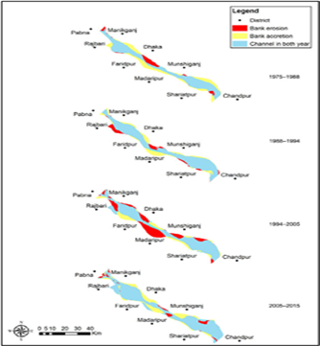

**Figure 2.3.2.1: Graphical Representation of River Bank Changes of the Padma River, Due to Erosion and Accretion for 1975-2015**

The channel through the Padma River is blocked by many sandbars named Islands or Char land. This channel usually disappears during winter and gets activated by water flow only during flood season. These are occurred due to the influence of active erosion and accretion. The statistical results, summarized in Figures 3 and 4 reveal the total water surface and islands area. The char area has increased significantly over time for the year of 1975, 1988, 1994, 2005 and 2015.

The analysis of data reveals the changes that the total amount of island was about 20,533 ha in 1975, 21,861 ha in 1988, 22,168 ha in 1994, 37,155 ha in 2005 and 50,966 ha in 2015.

**Figure 2.3.2.2: Map showing Padma River Blockage by Islands or Char Land**

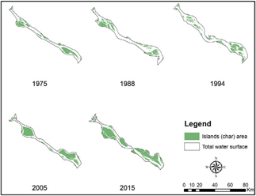

**Figure 2.3.2.3: Graphical Representation of the Total Water Surface During 1975-2015**

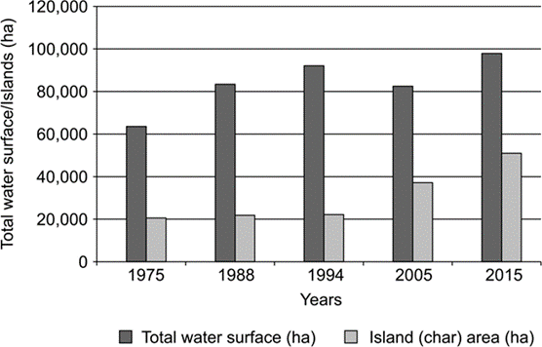

The shifting of bank line from 1975 to 2015 on both banks along the Padma river was measured through 10 cross-sections at an interval of 11.5 km along the river and the results are presented in Figure 5 and Table 3. Analysis of the satellite images of the research area showed that the highest amount of erosion of land observed in the left bank along the section G (4.1 km) from 1994–2005 near Munshiganj district and in the right bank along the section F (4.4 km) from 2005–2015 near Faridpur and Madaripur districts. The maximum amount of accretion of land was established in the left bank along the section I (3.6 km) near Munshiganj district and in the right bank along the section G (3.5 km) near Madaripur district from 1994–2005 and along the section K (3.5 km) near Chandpur district. The line diagram in Figure 2.3.2.4 indicates the direction and rate of shifting of bank line.

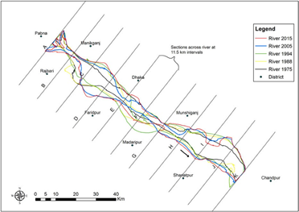

**Figure 2.3.2.4: The Line Diagram Indicates the Direction and Rate of Shifting of Bank Line.**

[Note: Minus sign (−) indicates shifting (in km) due to erosion and plus sign (+) indicates shifting (in km) due to accretion.] (Billah 2018).

**Table 2.3.2.5: Tabular Representation of the Bankline Shifting due to Erosion and Accretion 1975–2015.**

|  |  |  |  |  |  |  |  |  |  |  |
| --- | --- | --- | --- | --- | --- | --- | --- | --- | --- | --- |
| Sections | 1975–1988 | | 1988–1994 | | 1994–2005 | | 2005–2015 | | 1975–2015 | |
| Left  Bank | Right  Bank | Left  Bank | Right  Bank | Left  Bank | Right  Bank | Left  Bank | Right  Bank | Left  Bank | Right  Bank |
| A | +1.2 | +0.1 | –1.2 | −2.9 | −0.2 | −3.7 | +0.1 | −0.3 | −0.15 | −6.80 |
| B | +0.2 | −0.1 | −0.3 | −0.4 | −0.2 | +1.5 | −0.1 | +0.3 | +0.32 | +1.35 |
| C | −1.3 | +0.3 | −1.1 | +3.3 | +1.0 | −2.2 | −1.3 | +0.5 | −2.70 | +1.90 |
| D | −2.7 | −1.2 | +0.1 | −0.6 | −0.3 | −3.0 | −0.7 | +1.7 | +3.68 | −3.10 |
| E | +3.1 | −3.4 | −3.4 | −0.1 | +2.9 | +2.5 | −2.5 | −0.7 | +0.10 | −1.61 |
| F | +2.0 | −2.1 | +3.9 | −4.4 | −6.0 | −3.7 | +0.3 | −4.4 | +0.20 | −14.63 |
| G | +0.1 | −1.2 | −0.1 | −0.6 | −4.1 | −0.7 | −0.2 | +3.5 | −4.30 | +1.00 |
| H | +0.7 | −1.3 | −0.1 | +0.8 | −1.2 | −1.4 | +0.7 | ±0.7 | +0.10 | −2.60 |
| I | −2.2 | −0.8 | −1.1 | –0.6 | +3.6 | −0.8 | +2.0 | −0.7 | +2.30 | −2.39 |
| J | −2.0 | −1.7 | −1.1 | −0.9 | +0.2 | −0.1 | +0.1 | +1.2 | −2.85 | −1.47 |
| K | −0.3 | −3.8 | +1.5 | +1.5 | −1.5 | +3.5 | −0.1 | +1.0 | −0.31 | +2.20 |

**Chapter 3: Scenarios of the Problem in Global and Regional Contexts**

**3.1 Case Based Scenario or Condition**

Bangladesh, a riverine country, is suffering heavily from River bank erosion. Thousands of Bangladeshi population were forced to migrate from their place of origin thanks to bank erosion. The foremost rivers of Bangladesh are Padma, Jamuna and Meghna. These 3 rivers have worn many thousand hectares of flood plain, many Kilometers of roads and railways and have displaced individuals. Lately, the Ganges-Padma a decorated watercourse attributable to high sediment transportation a decorated watercourse attributable to high sediment transportation by Jamuna and deposition of Ganges-Padma watercourse bed (Yeasmin and Islam, 2011).

Throughout 1970 – 2000, 2 major rivers of People's Republic of Bangladesh, Padma and also the Jamuna worn a hundred and eighty 000 hectares of land and regarding 2, 00,000 individuals were displaced (Islam and Rashid, 2011). Displaced individuals experienced substantial socio-economic impoverishment and marginalization attributable to forced migration and inequitable access to land and alternative resources (Mutton and Haque, 2004). Another erosion afflicted country in Asia is Myanmar. Erosion of watercourse banks on the Irrawaddy River and Chindwin rivers in Magway Division, central Myanmar is common throughout the time of year and riverine communities are oftentimes compelled to migrate (Mann, 2013). Some families shifted many times throughout 1993 to 2012 and lost everything. In spite of the government's initiative very little has been done to stop more erosion.

More than 80% of the rural population in Bangladesh is employed in agriculture. The loss of land due to riverbank erosion should reflect the surplus supply of agricultural labor. In view of this, one would have expected higher unemployment among the displacers, particularly for those who have lost whatever little cultivable land they had (Halli, 1991). Due to loss of land by river bank erosion the displacers had no other alternatives but to move to a new place for resettlement or for temporary shelter. Those who moved away from an area were different in many ways than those who tried to remain. It has been observed that the riverbank erosion does have an impact on the displaced population of Kazipur Mobility of people from riverbank erosion area has a profound economic and social impact in the community (Meshah, 1991).

**3.1.1 Padma River Erosion**

Bangladesh is placed within the geographical region delta that was developed by 3 mighty rivers i.e., the Ganges, the Brahmaputra and therefore the Meghna (GBM) (Rahman and Islam 2016). The sediments square measure deposited within the GBM basin is the highest in quantity within the world (Kuehl et al. 1989). It's been calculable that, regarding 1050 million heaps of sediments annually discharged from the geographical region basin (Milliman et al. 1995), among 600 million tons’ square measure deposited within the geographical region delta (Meade 1996). As a result, the stream beds in GBM square measure silted up and lose their depth. Thanks to over-siltation the stream configuration is being adjusted oftentimes and therefore the stream channel is shifting repeatedly.

These phenomena square measure liable for stream flood and bank erosion within the country (Elahi et al. 1990). A network of rivers of the Padma, the Jamuna, the Teesta, the Brahmaputra, the Surma, the Meghna and their tributaries covering the country with a high length of regarding twenty-four, 140 klicks (BBS 2011) additional or less all the rivers of People's Republic of Bangladesh square measure liable for erosion at varied points and annual rivers worn ten, 000 angular distance of land in People's Republic of Bangladesh (NWMP 2001). Between 1973 and 2004, about 877.90 km2 of land had been worn on the Jamuna (Lower Brahmaputra) and 293.90 km^2 on the Padma (Lower Ganges) (CEGIS 2009) on the line of credit their square measure 283 locations, eighty-five cities and growth centers square measure prone to erosion (Islam and Rashid 2011) and regarding 15–20 million folks square measure in danger from the results of abrasion (Hutton and Haque 2003; Rahman et al. 2015).

As a result, an outsized range of individuals become homeless thanks to stream bank erosion and that they migrate to cities or nearest city and sleep in the urban slum areas (CEGIS 2009; Das and Bela 2011). In conjunction with field and settlement, the country conjointly loses many kilometers of roads, railways, and control embankments annually. No alternative disasters square measure as faithful as bank erosion in terms of long run impact on folks and society (Elahi 1991). The river named Padma in People's Republic of Bangladesh half is a vital stream system in South Asia that supports the life and livelihoods of countless folks.

**Table 3.1.1: Tabular Representation of the River Bank Erosion in Padma River during the Period 1973-2017 in Different Districts.**

|  |  |  |
| --- | --- | --- |
| **District** | **Eroded area (Ha)** | **Accreted area (Ha)** |
| Manikganj | 7,139 | 36 |
| Rajbari | 640 | 55 |
| Faridpur | 8,763 | 4,525 |
| Dhaka | 2,564 | 15 |
| Munshiganj | 5,971 | 29 |
| Madaripur | 2,592 | 3107 |
| Shariatpur | 9,627 | 6,478 |
| **Total** | 37,296 | 14,246 |

**3.1.2 Ganges River Erosion**

The Ganges River system, with a geographical area of 1.09 million km2, originates at the Gangotri ice mass within the Himalayas and is one in every of the biggest stream systems within the world. On its 2526 klick course to the confluence with the Meghna, it crosses China, Nepal, Asian nation and People's Republic of Bangladesh, creating it an example international stream. Asian nation has the biggest share (79.1%) of its entire structure whereas solely 43% lies among People's Republic of Bangladesh that is corresponding to thirty second of the country and receives average annual precipitation of 1200 millimeter (Mirza 2004; Sulser et al. 2010). it's thus, subject to high seasonality and continual floods of huge magnitude (Sharma 2005) with eightieth of the annual total discharge volume occurring throughout the monsoon season i.e., July–October (Kale 2003).

Erosion and deposition statistics of the river indicated that fifty-seven km2 of land was lost on the proper bank whereas around fifty-nine km2 was gained on the vicinity throughout the amount of 1973–2011 (Dewan et al. 2017). Along the course of Padma in People's Republic of Bangladesh, the foremost severe bank erosion is discovered within the areas of Harirampur, Faridpur Sadar, Char Vodrasion, Dohar, Mawa Ghat, Shiv Char, Tongibari. Harirampur is taken into account because it has the most erosion-prone space among the opposite elements. The folks of this space square measure the foremost vulnerable community within the lower river field and their fate is regulated by the dynamic stream character. Each development sector of this space bears the adverse impact of the erosion.

Thanks to vast socio economic losses the folks of this space square measure thought-about because the most terrible cluster that don't seem to be properly addressed by the scientific community. antecedently several researchers i.e., Elahi et al. (1990), Rogge (1991), Dewan and Nizamuddin (2000), Mirza (2004), Rahman (2010), Uddin and Rahman (2011), Chatterjee and Mistri (2013), Rabbi et al. (2013) and Dewan et al. (2017) studied on bank erosion standing supported geographical and earth science purpose of views. During this circumstance, the current study aimed to research the bank erosion hazard of the stream Padma close to Hari Rampur–Char Vadrasion web site and its impacts on socio-economic condition of the inhabitants in study space. The study conjointly supposed to spot the potential vulnerable areas thanks to bank erosion, for additional disaster management action.

**3.1.3 Jamuna River Erosion**

Riverbank Erosion a virus and continual natural hazard in Asian nations. Once rivers enter the Mature stage (as within the case with the 3 mighty rivers, Ganges, Brahmaputra and Meghna) they Become sluggish and meander or braid. These oscillations cause large bank erosion. Every Year, a lot of folk’s square measure is stricken by erosion that destroys standing crops, farmland and homestead Land. It’s calculable that concerning five-hitter of the whole flood plain of Asian nations is directly stricken by erosion. Some researchers have rumored that bank erosion is going down in ninety-four out of 489 Upazilla of the country. Some alternative researchers have known fifty-six Upazilla with incidence of abrasion. At present, Bank erosion and flood hazards in nearly one hundred Upazilla became nearly an everyday feature. Of these 35 square measures are severely affected. For instance, a newspaper report declared that over twenty-five, 000 families were Rendered homeless in Gregorian calendar month 1993 by bank erosion in sixteen districts.

Some rivers cause erosion in large scale and high frequency because of their unstable character. These rivers assume a decorated pattern consisting of many channels separated by tiny islands in their courses. Throughout the last two hundred years, the channels are swinging between the most natural depression walls. Throughout the monsoon, extensive over bank spills, bank erosion and credit shifts are typical square measures. The gradual migration or shifting of channels of the key rivers in Asian nations quantity to anywhere between 60m to one, 600m annually. In a typical year, about 2,400 klicks of credit experience major erosion.

The unpredictable shifting behavior of the rivers and their encroachments not solely have an effect on the agricultural floodplain population however also urban growth centers and infrastructures. No general pattern has however been discovered of the erosion hazards owing to the involvement of a large number of variables within the method. The intensity of bank erosion varies widely from watercourse to river because it depends on such characteristics as bank material, water level variations, close to bank flow velocities, set up type of the watercourse and also the offer of water and sediment into the watercourse. For instance, loosely packed, recently deposited bank materials, consisting of SILT and fine SAND, and are highly susceptible to erosion. Speedy recession of floods accelerates the rates of bank erosion in such materials.

The Jamuna may be a decorated watercourse with bank materials that square measure extremely liable to erosion. The Jamuna stream has been rising apace from even before the beginning of the season this year, causing severe stream erosion in Jamalpur. Homesteads, croplands and alternative necessary structures have either been lost to the stream already or face close at hand erosion in Dewanganj and Islampur Upazilla. Some two hundred families became marooned when losing their ancestral homes and land in Kholabari underneath Chikajani union in Dewanganj. Moreover, the recently designed Bahadurabad steps stream police office within the same Upazilla is additionally in danger because it could also be eaten up anytime. The three-storied building was designed at a value of Tk5.8 large integers and was inaugurated on April half-dozen, 2019.

Meanwhile, around twenty-five families in Noarapara and Belgachha union underneath Islampur Upazilla, falling victim to the erosion, an area unit passing their days in misery while not water and food underneath the open sky. The cause behind the untimely stream erosion is the desiccation of the channel on the western bank of the Jamuna for approximately one and a 0.5 kilometers, inflicting the water to flow in a very sturdy current through the Japanese facet. As a result, the erosion at Kholabari, on the east bank of the stream, has magnified. The native exploitation Board (WDB) has been selling sandbags at vulnerable mound areas for the last fortnight to forestall additional erosion caused by the rising tides of the Jamuna. However, locals say selling sandbags at the affected bank areas is proving to be ineffective because of the sturdy currents prevailing within the Jamuna.

**3.1.4 Meghna River Erosion**

The Meghna River is one among the foremost and holiest rivers in Bangladesh, one among the 3 that type the Ganges Delta, the most important delta on earth, that fans dead set in the Bay of geographical region. The Meghna is that the widest stream among those who flow utterly within the boundaries of Bangladesh. To some extent close to Bhola, Meghna is thirteen klicks wide. In its lower reaches, this river's path is sort of absolutely straight.

River erosion in 2018(the daily star) by the Meghna river in Nasirnagar Upazilla has created panic among the people of the area. More than 20 shops and 15 homesteads in Chatolpar Chawkbazar have gone to the riverbed due to untimely erosion. Over 100 establishments, including shops and homesteads, are under threat of erosion now. It severely destroys human settlements, agricultural lands and people’s fireplaces and residences leading to the displacement of thousands of individuals each year. The socio-economic impacts of watercourse bank erosion in Bangladesh is one amongst the principal contributors to the method of marginalization of the rural class.

Locals say illegal and random sand lifting round the year is one of the main reasons of river erosion. Besides, the river has also been shrunken by chars (landmass emerging from the riverbed) that create strong currents adjacent to Chatolpar bazar and village areas. River bank erosion exerts widespread effects on the life and property of the folks. In additional recent years, watercourse bank erosion has been a perennial option on the key and a few minor rivers in Bangladesh.

Like in alternative places bank erosion within the Meghna watercourse conjointly broken and scoured away thousands of hectares of housing and agricultural lands displacing thousands of individuals. They knew chars and khas lands, close villages Sonargaon several them took shelters slums Sonargaon, Narayangnaj, Dhaka cities alternative places urban areas. Results from survey showed that when displacement virtually the became absolutely landless.

**3.1.5 Brahmaputra River Erosion**

Most of the studies on Brahmaputra river bank erosion in Assam have been aimed at identifying factors causing erosion and assessment of eroded geographical area. Such studies are important for taking erosion control measures and restoration ([Sarma and Acharjee, 2012](http://lrlr.landscapeonline.de/Articles/lrlr-2014-3/refs.html" \l "ref-Sarma2012)). However, little effort has been made to quantify the loss due to this erosion though it is often reported that Brahmaputra River bank erosion causes poverty, has a long term impact and there is no compensation mechanism ([Talukdar, 2012](http://lrlr.landscapeonline.de/Articles/lrlr-2014-3/refs.html" \l "ref-Talukdar2012)). It has already been mentioned that Brahmaputra bank erosion has wiped out a large area including human settlements, productive cropland and reserve forest area. One of such affected areas consists of some community Development Blocks of Barpeta district of Assam. Such a Block is Mandia.

Brahmaputra River erosion (Khan, 2012). In Mandia Block agriculture was the primary occupation of the majority of the people. But due to bank erosion there was loss of agricultural land, which in turn has increased the number of landless laborers. The percentage of landless laborers among the working class in the study area was nearly 90 percent, whereas it was only 16 percent in Barpeta district, where this block belongs. Decreasing agricultural land due to erosion and at the same time increasing the number of landless laborers had obviously an impact on their livelihood. This was observed from a growth in the number of poverty stricken people in Mandia Block. The portion of population below the poverty line in this block was more than double that in Barpeta district.

Poverty in turn escalated illiteracy and malnutrition of the children due to lack of education attainment and improper care for health. Existing medical centers in the previously eroded settlement were affected due to erosion. Moreover, in most of the new occupied places (generally, river embankments, road sides, or lowlands, which are mostly inundated by flood) physical (viz., road, electricity, etc.) and social infrastructures were either absent or not adequate. Brahmaputra River erosion created problems of identity, too. Sometimes the displaced persons were suspected as illegal migrants (as the Bangladesh border is very close to the study area), especially when they were in search of jobs for their livelihood. On the other hand, some displaced persons forcibly occupy lands in reserve forests, and cause deforestation which lead to not only ecological degradation, but also scarcity of fuel wood and fodder in the region. Thus, Brahmaputra river bank erosion has caused both socioeconomic and ecological imbalance.

**3.2 Compare with Other Countries and Global Perspective**

**3.2.1 America**

The larger the drainage basin of a wandering watercourse, the quicker is its channel migration. The speed of channel migration isn't the same for all rivers with constant drainage basin. This happens as a result of the speed of migration additionally depends on the fabric that constitutes the watercourse banks. This is often precisely what happens within the case of Guadalupe watercourse (a wandering river) within the USA, wherever the speed of abrasion is a smaller amount than expected (Gantt and Humberson, 2004).

**Figure 3.2.1.1: Graphical Representation of The link between the watercourse channel migration rate and also the drainage basin of the watercourse (Hudson and Kesel, 2000).**

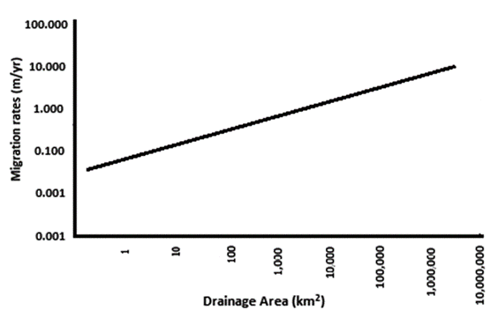

Both Mississippi and Missouri Rivers are facing meander migration. It’s a method during which water flow erodes soil on one bank and deposits it on the alternative bank, i.e., a gradual shift of credit line happens over time (Briaud et al., 2007). The river bank is eating away at a high rate on the Lower Brule Reservation Central Mount Rushmore State within the USA. The Lower Brule Siouan Tribe (LBST) has calculated that the reservation is losing its bound in some locations at a rate of roughly eight feet p.a. (Neitzert et al., 2012). The semi-permanent impact of bank erosion on cultural and environmental losses is below investigation. The river may be a major tributary of the Mississippi within the USA.

Most of the geographical region is set within the State of Illinois. The stream has been dynamic its course through bank erosion since the year 1939 chiefly thanks to construction of locks and dams to facilitate the movement of stream traffic (Bhowmik, 2008). Bank erosion has been occurring as a result of a variety of natural forces and human iatrogenic activities. The analysis has shown that concerning seventy-four % of the bank erosion sites were thanks to flow flows. Concerning twenty-eight % of the bank sections have shown the proof of stream traffic iatrogenic impacts. conjointly there are alternative factors like eddy currents, disturbed flows thanks to exposed tree roots, surface voidance, etc. that caused erosion.

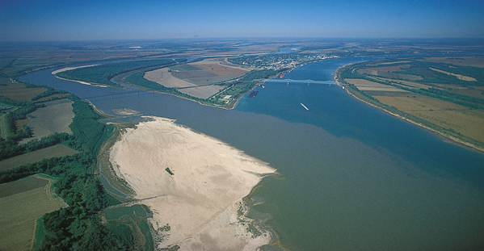

**Figure 3.2.1.2: Mississippi river**

**3.2.2 China**

The Yellow river (or Huang He) is the second largest river in China, once the river. The stream meanders for 5000 kilometers through 9 provinces and a watershed of about 680 000 km2. The stream was known as “China’s Sorrow” owing to frequent occurrences of flood on the stream and sufferings of ample individuals. The worst flood disaster in world history occurred in August 1931 on this stream associate degreed killed a calculable three.7 million individuals. The Sanmenxia Dam on the Yellow River was created in 1960 to forestall floods, offer water for irrigation, and manufacture electricity power.

However, vital silt masses within the Yellow River weren't adequately thought of within the starting stage. The reservoir water basin was for the most part full of silt solely four years once construction, and therefore the reservoir was afterwards taken out of operation. In subsequent years 3 additional dams were constructed: Liujiaxia Dam in 1968, Longyangxia Dam in 1985, and Xiaolangdi Dam in 1997. Two vital river bank erosions were observed: one throughout 1961 to 1964 related to completion of Sanmenxia Dam, and therefore the difference throughout 1998 to 2004 related to completion of Xiaolangdi Dam (Ma et al., 2012).

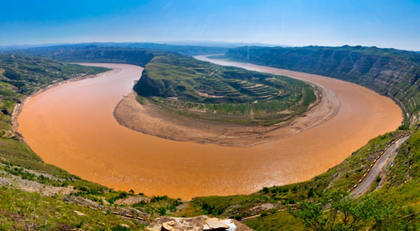

**Figure 3.2.2: Yellow River**

**3.2.3 Africa**

The Nile is the longest river (6650 km) in the world and passes from south to north through eleven countries in Africa, namely Ethiopia, Eritrea, Sudan, Uganda, Tanzania, Kenya, Rwanda, Burundi, Egypt, Democratic Republic of the Congo and South Sudan. The Nile meanders through a watershed that is to more than 30 percent arid ([Wong *et al.*, 2007](http://lrlr.landscapeonline.de/Articles/lrlr-2014-3/refs.html#ref-Wong2007)). The lateral erosion on the Nile river banks in Egypt is another example of river bank erosion. Nile river meandering and the associated processes of bank erosion and deposition accelerated with human activities. Erosion has its impact on both economy and environment. Bank erosion has caused decrease in agricultural lands which in turn has reduced the agricultural production ([Ahmed and Fawzi, 2009](http://lrlr.landscapeonline.de/Articles/lrlr-2014-3/refs.html#ref-Ahmed2009)). It has been recommended to protect the river bank from further movement and erosion.

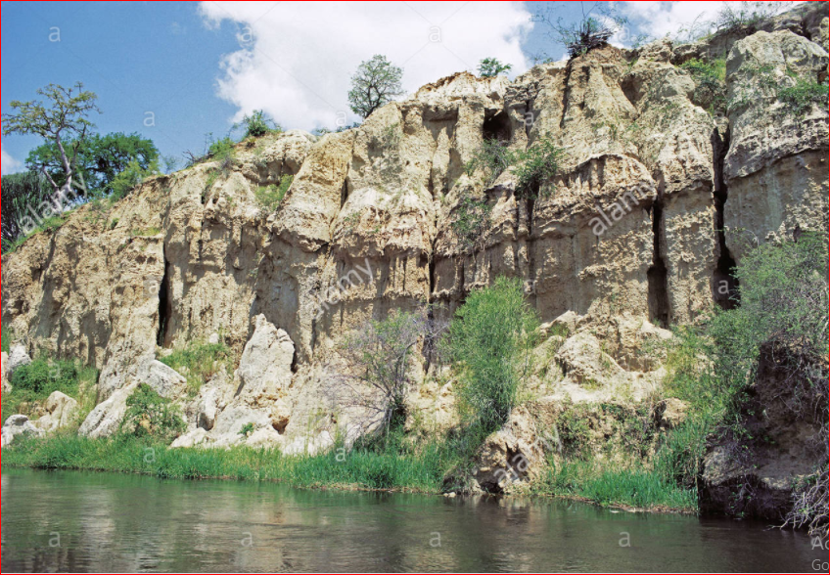

**Figure 3.2.3: Eroded earth cliffs on northern bank of River Nile seen from launch Murchison Falls National Park Uganda East Africa**

**3.3 Future Scenarios and Concern**

**3.3.1 Future Scenario Discussion**

Riverbank erosion is considered as one of the significant catastrophic events in Bangladesh which causes untold miseries each year to a huge number of individuals living along the banks of the streams. The predictions made about our future regarding river bank erosion are not just obscure imaginations of some experts, but very factual threats. However, it is very difficult to predict river bank erosion as it is tough to observe the systematic pattern of the erosion hazards because of the involvement of a large number of variables in the procedure. The intensity of bank erosion differs extensively from river to river as it depends on such features as bank material, water level variations, near bank flow velocities, plan form of the river and the supply of water and sediment into the river. The expected riverbank erosion for 2050 and 2100 are presented in Table 1 which displays a rise in the average yearly erosion rate is greater for the Jamuna and the Padma by 2050 than that by 2100. Then again, the Ganges is in an equilibrium point for 2010-2050 and 2050-2100 periods (Aktar, 2013).

**Table 3.3.1.1: Predicted riverbank erosion along the Jamuna, Ganges and Padma Rivers**

|  |  |  |  |
| --- | --- | --- | --- |
| River Name | Erosion in 2010 | Erosion by 2050 (% increase from base) | Erosion by 2100 (% increase from base) |
| Jamuna | 2700 | 3250 (20.7%) | 3450 (27.8%) |
| Ganges | 1850 | 1900 (2.7%) | 1950 (5.4%) |
| Padma | 1500 | 1700 (13.3%) | 1750 (16.7%) |
| Total | 6050 | 6850 (13.2%) | 7150 (18.2%) |

CEGIS has reported erosion forecast for the Jamuna, the Ganges and the Padma rivers for the year 2020 (Mallick et al., 2019). Another gauge by Intergovernmental Panel on Climate Change says by 2050, around 50 million individuals will migrate of environmental change. Because of riverbank erosion, individuals are compelled to relocate from their places of root to different spots (Fahad, 2018).

**Table 3.3.1.2: Erosion Prediction for 2020**

|  |  |  |  |  |  |  |  |
| --- | --- | --- | --- | --- | --- | --- | --- |
| River | District | Land (ha) | Settlement  (ha) | Educational institute | Hat/Bazar | Health Centre | Mosque/ Mondir |
| Jamuna | Kurigram  Gaibandha  Bogura  Sirajganj  Tangail  Jamalpur  Manikganj | 363  292  136  278  556  24  161 | 62  68  12  61  164  10  24 | 6  7  1  20  4  1  1 | 0  0  0  1  1  0  0 | 0  1  1  1  0  0  0 | 5  5  0  5  7  0  0 |
| Ganges | Rajshahi  Pabna  Rajbari | 86  110  564 | 1  5  26 | 0  0  3 | 0  0  1 | 0  0  0 | 0  0  1 |
| Padma | Faridpur  Shariatpur  Madaripur | 435  600  875 | 21  226  105 | 1  11  0 | 0  4  0 | 0  3  0 | 1  18  1 |
| Total |  | 4480 | 785 | 55 | 7 | 6 | 43 |

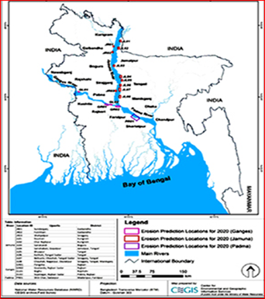

**Figure 3.3.1.3: Experts predicted River Erosion in Northwest for the year 2020**

Professional studies forecasts river erosion specifically focuses in a few northwestern and central regions this year, looking for defensive measures for structures and farmlands as heavy rains and spouting waters from upstream kept on blowing up the streams in upper riparian zones. Specialists at CEGIS, a communal trust under water resources ministry purview, said their studies on river morphology in 2020 proposed that 16 precise localities in 12 northwestern, central and southwestern regions could be exposed to erosion in coming months, reports BSS (Chowdhury, 2020).

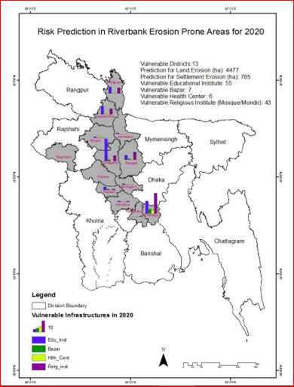

**Figure 3.3.1.4: Riverbank Erosion Prone Areas for 2020**

**3.3.2 Who are Responsible for Predicting Riverbank Erosions?**

CEGIS (Centre for Environmental and Geographic Information Service) are responsible for predicting riverbank erosion in the major rivers in Bangladesh. CEGIS has developed methods to predict morphological changes, including bank erosion of the Jamuna, Ganges and Padma rivers. The methods are being used since 2004 to predict bank erosion and morphological changes of these rivers (Unb, 2015). They always try to predict the riverbank erosion in the major rivers one year in advance. For the past three years CEGIS are constantly introducing different tools in order to predict river bank erosion for the Jamuna, the Ganges and the Padma rivers. River, Delta and Coastal Morphology Division is in charge for morphological forecast using GIS and RS systems.

Even they play a part in all EIA and SIA studies in the water segment plans to evaluate effects on river morphology and are involved in observing the ecological effects by large water division projects. For the last two decades CEGIS has developed tools and techniques mainly using spatial data which include historical maps, time series satellite images, to conduct study on fluvial, tidal and coastal morphology, especially applicable for very dynamic system (The CEGIS Newsletter, 2018) The Ministry of Food and Disaster Management is liable for building awareness in pre-catastrophe stage and appropriating help merchandise in post-calamity stage just as recoveries in some expand. Certain areas of displaces are obliged in designation of Khas land, Adarshaya Gram and Abashon ventures. NGOs like CARE-Bangladesh, OXFAM, BDPC and RDRS are working with displacees in specific territories of Bangladesh (Islam, 2012).

**3.3.3 Tools for Predicting Riverbank Erosion**

Various tools are being use by the expert to predict riverbank erosion nowadays. Some of them are described below:

1. **Time series Dry Season Satellite**- CEGIS has advanced a completely unique device for predicting the riverbank erosion three hundred and sixty-five days in advance of the Jamuna, the Ganges & the Padma Rivers primarily based totally on time series dry season satellite for pc images. This prediction is a probabilistic method and CEGIS has been predicting the erosion inclined places alongside each banks of those rivers considering that 2004 for 3 one of a kind probability (30%, 50% & 70%). The basic accuracy of this device

levels from 70% to 80% which may be taken into consideration as pretty precise thinking about the uncertainty in fluvial process.

1. **Shear Stress Approach**- The bank erosion is anticipated by coupling the mathematical model outcomes with the abundance shear pressure approach. Shear stresses were determined by mathematical model reproduction of the mean every day streams or flood event basis. Using estimated parameters streambank erosion rates are basically predicted for a historic storm event on a local stream to calculate the outcome of variances in the estimated parameters values on erosion forecasts (Osman et al., 1988).

**3.3.4 Future Concerns**

Every year in Bangladesh, millions of individuals are affected by erosion that demolishes standing harvests, grazing and farmstead terrestrial. It is assessed that about 5% of the all-out floodplain of Bangladesh is straightforwardly influenced by riverbank erosion (Islam, 1995). Nonetheless, nowadays, riverbank erosion is viewed as one of the significant reasons for poverty. The level of financial misfortune and weakness of populace because of bank erosion has drastically expanded as of late. The effect of land loss includes principally the loss of property land, lodging structures, crops, cows, trees and family utensils. Loss of estates forces individuals to migrate with no alternative and places them in deplorable circumstances.

Around 1,000,000 individuals are straightforwardly influenced every year by bank disintegration in the nation. The all out money related misfortune is assessed to be roughly $500 million every year. An expected 300,000 uprooted people generally take cover on streets, banks and government-demanded lands (Islam, 1995). Hence it’s a huge concern for the government to tackle this problem each year. Bangladesh Government is constantly looking for ways to combat river bank erosion. Earlier they used to throw sandbags on crumbling land but this doesn’t help much so they are looking for alternate plans now.

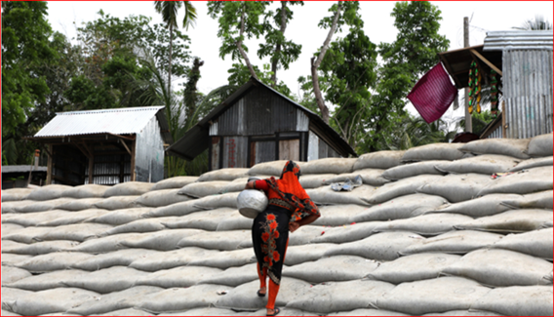

**Figure 3.3.4.1: Local authorities have placed sandbags to reinforce riverbanks near Kedarpur village.**

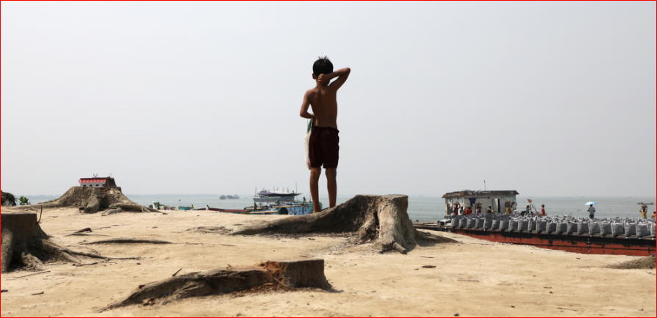

**Figure 3.3.4.2: A lad watches river defense work nearby Kedarpur village. Experts are reinforcing the banks with sandbags and concrete constructions.**

Bangladesh Water Development Board, the public authority office that supervises the administration of waterways in December began a $130-million undertaking proposed to shield a nine-kilometer stretch of Naria from additional disintegration. This incorporates the digging of streams to eliminate overabundance silt which can redirect a waterway's stream and add to erosion and introducing barricades and solid squares to brace the precarious riverbanks.

There are likewise plans to raise structures in the waterway that would divert water away from the delicate banks, said venture head Prakash Krishna Sarker (Alam,2019). As only throwing sandbags on the banks are not working so beside sandbags concrete structures are being in the process of construction which would be completed by next three years. Hence people over there are concerned about how they will survive if river starts to erode in the next year as the construction is still under process (Alam, 2019).

Bangladesh's administration a year ago affirmed a multi-billion-dollar framework intend to more readily deal with the nation's streams, including handling erosion. AKM Enamel Hoque Shameem, the agent serves for water assets, said the plans incorporate digging, stream preparing, and bank insurance. He revealed to The New Humanitarian that disintegration weak regions like Shariatpur are a "first concern" (Alam, 2019).

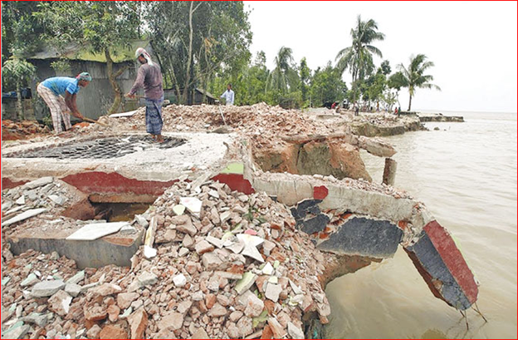

**Figure 3.3.4.3: Construction in process to prevent Padma Riverbank Erosion.**

Environmental refugees are another concern of the government. Every year it’s a serious headache for the government to arrange shelter for the people residing near the risky areas as chances of happening series damage due to river bank erosion is very high. Finding shelters is a big concern for the refugees as in this situation they need help from others and government doesn’t always accommodate them properly so they take shelters in their relatives place mostly.

It was apparent that, the vast majority of displace were taken sanctuary to their family member or neighbor's home soon after relocation. The reason to pick this alternative was distinguished as more secure spot than others were (Islam 2012). Government built temporary shelters in few areas for these refugees. Another concern is shortage of food supply for the refugees. It is difficult to provide food to the affected areas. It is common in Bangladesh that the survivors of riverbank erosion don't get same reaction from the concerned specialists as gotten by the casualties of flood who have made sure about significant spots in the rundown of catastrophes. On account of its moderate cycle and dissipated frequencies, displaces of riverbank erosion neglect to draw consideration effectively of the capable specialists (Islam, 2012). Loss of land is another concern of the country. During monsoon season, every year Bangladesh loses a huge portion of land due to river bank erosion. A zone of land approximately five times the size of Dhaka has been lost to the Padma and Jamuna streams in Bangladesh in the course of recent years, a report of the Center for Environmental and Geographic Information Services (CEGIS) has uncovered (Hasnat, 2018).

Unemployment might right due to river bank erosion. People will lose their job because there working place floating by the flood. As they will have no job there is a threat to become a poor because they have lost their property, possessions and human life. Even because of horrible condition of the river bank erosion people will lose their shelter and they will take shelter school, college etc. So there will be no choice to carry on the lesson and also the victim learners will lose their books. And pupils will face problem during their exam. When the people will lose everything by the river bank erosion and shortage of cash that time in casualty’s mind criminal activities might grow and it will create the problem of social security. The fundamental concern of the affected region of riverbank will be transport. It is often found that afterward a flood the road way communication become so much hindered that the zone become paused due to lack of suitable commination system. Hence, the values of different goods start to rise unceasingly and it generates a socio economic concern for both the Government and the citizen.

**Chapter-04: Results and Discussion**

**4.0 Results and Discussion**

Bangladesh is the largest delta in the world, formed by the Ganges, the Brahmaputra, and the Meghna river system (Rahman 2010). This delta is characterized by flat terrain interlaced with an intricate system of about 700 rivers, canals, and streams, with a total length of approximately 22,155 km (BBS 1979, 1984), which carry an enormous quantity of sediment-laden water downstream. Over 92 percent of the annual runoff generated in the GBM area flows through Bangladesh, which is only about 7 percent of the total catchment’s area (Ahmad, 2000). Thus, a vast amount of water flows through Bangladesh. It is estimated that every year an average of 870 Million Acre Feet (MAF) of water flows into the country from India (Rahman 2010).

The amount of rainfall received within the country is estimated at 203MAF, with evaporation, evapotranspiration, and deep percolation losses probably accounting for about 120MAF (Rahman 2010). This means that about 953MAF flows out to sea–from that 914MAF flows through the Ganges, Brahmaputra delta (within Bangladesh), and 39 MAF through the rivers of the Chittagong sub-region and Feni district (Rashid 1991). During the peak flow season (July-September) most of the rivers normally overflow their banks onto the low-lying surrounding flat land, which is essential for providing vital moisture and fertility to the soil (Rahman 2010).

However, occasionally abnormal conditions lead to drainage congestion, excessive rainfall runoff, and storm-tidal surges that induce high-magnitude flooding that inundates large areas, and causes widespread damage to crops and property (Rahman 2010). The devastating floods of the recent past are due to excessive rainfall in the GBM catchment area, and synchronization of peak flow of the Ganges and the Brahmaputra-Jamuna rivers (Rahman 2010). The likelihood of abnormal floods is also increased due to infrastructure development activities that neglect proper concern about environmental impacts and drainage facilities (Rahman 2010). An analysis of hydrographs and other hydrological data of a few selected stations indicated the following salient features (Haque and Zaman 1993). The synchronization of backflows of the major rivers accounts for the floods in the years 1954 (30 days), 1974 (27 days), 1987 (30 days), and 1988 (30 days). The synchronization accentuated the disastrous and catastrophic flood of 1988.

The mean annual rainfall in Bangladesh varies from about 1400mm in the western part of the country, to almost 5000mm in the northeast region (Rahman 2010). There are wide seasonal fluctuations, with about 90 percent of the rainfall occurring during the four months of the monsoon period (June-September). A number of constraints are inherent in this monsoon-dependent rainfall and climatic pattern, which can lead to excessive amounts of rainfall and floods, or inadequate rain resulting in drought. Along with the floodwater, the rivers of Bangladesh carry huge amounts of sediments, an estimated 2.4 billion tons/year (Rahman 2010). The sediments are washed down from highlands on three sides of the Basin, particularly from the Himalayas, where the slopes are steeper and the rocks are less consolidated (Rahman 2010). Erosion plays an important role in the siltation process, and the water-holding capacity of rivers. The deterioration of the river system due to siltation is one of the causes of floods in Bangladesh (Rahman 2010).

The river sediments are subjected to coastal dynamic processes generated mainly by river flow, tide, and wind actions (Rahman 2010). The ultimate result may be additional new land in some places due to accretion, and loss of land in some other places due to erosion. As a result of sedimentation, the formation of chars (islands) through accretion takes place (Rahman 2010). These undesirable chars in the river system threaten inland water navigation, cause erosion in the riverbanks, and create other socio-economic problems for people due to land loss and displacement (Rahman 2010). Erosion in the coastal regions of Bangladesh is caused by a number of factors, such as high monsoon wind, waves, and currents, strong tidal actions, and storm surges (Ali 2000).

Even Bangladesh may lose 2,270 hectors of lands to erosion (Siddique 2018, Dhaka Tribune). Cegis (Centre for Environmental and Geographic Information Services) has predicted 22 probable vulnerable locations for this year along both banks of the Jamuna, the Ganges and the Padma rivers which are vulnerable to riverbank erosion (Siddique 2018). In 2017, Cegis predicted 29 locations out of which 20 are in the Jamuna, five in the Ganges and four in the Padma River. In September 2018, over 13,000 people of Naria upazila became homeless due to the erosion by the Padma. At least 200 businesses at Sadhur Bazar and 200 shops at Wapda Bazar disappeared in the Padma. The Cabinet Committee on Economic Affairs in November 2018 approved a proposal to protect Zajira and Naria Upazilla of Shariatpur from river erosion at a cost of Taka 1,077.58 crore (Saurav 2020).

In 2020 people of Satkhira and Khulna are also affected because of river bank erosion. So riverbank is really affected char area and other Bangladeshi location a lot. We need to take necessary precaution for preventing this disaster.

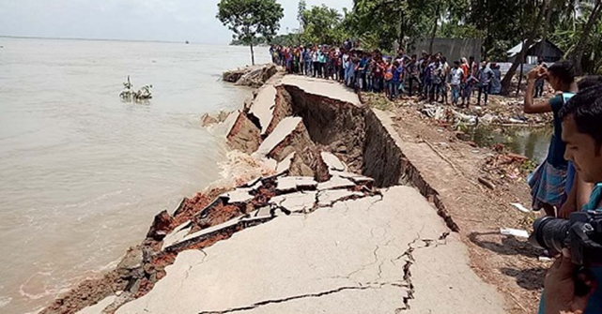

**Figure 4.0: The disaster situation occurs in char areas and other Upazilla.**

**4.1: Relation between Population Displacement and River Bank Erosion.**

There is a connection between population displacement and river bank erosion. When River bank erosion occurs people lose their home, their places to live so they move to another place. River Bank Erosion is a one of the common natural disaster in Bangladesh (Eva, Hazra ET). Land degradation due to river bank erosion is reported at the beginning and at the end of the monsoon season in the Tetulia and other rivers of Bangladesh. Towards the beginning (May to July) the Tetulia devoured Najirpur and Dhulia Union of Bauphal upazila in Patuakhali district (Eva, Hazra ET). The continuous erosion of the Tetulia River devoured about 1000 acres of cultivable land, 210 house-holds two bazars, three primary school, and 10 mosques under water in last 15 years (Eva, Hazra ET). Two study unions such as Najirpur and Dhulia union of Bauphal upazila in Patuakhali district are the most erosion prone area. There is a list that shows how many people are eroded in Bhaupal upazila just in 10 years.

**Table 4.1: Tabular Representation of River Bank erosion in Bhapal Upazilla**

|  |  |  |
| --- | --- | --- |
| Union | Area(ha) | Eroded |
| Dhulia | 276 | Char Basudipasa |
| Najirpur | 195 | Char Kochua |

Source: Upazilla Nirbahi Office (Bhaupal).

**4.1.1: Population Settlement in Newly Developed Area**

Newly developed char land has been given to landless people (Eva, Hazra ET). People living in the char area migrated from one place to another for losing their accommodation. In the study area Bauphal Upazilla, Dhulia union and Chandradip union there are two char land developed namely Char Basudibpasa and Char Kochua where live population. In Char Basudibpasa population settlement was starting in late 1996. More than 5000 people living here and Char Kochua population settlement was starting 1960, more than 8000 people living here. Among these Char, Char Kochua is the oldest char (Eva, Hazra ET). It is emerged about sixty years ago. It is also larger than the other char. Char Basudibpasa is latest char and people leaving here from twenty years ago. In the study area accretion of soil is continued and formed new land. So people from Bhaupal migrated to char area for their newly developed life.

**4.1.2: The Raw Source of Displacement**

A study was done about the originality of migrated peoples. Like where do they belongs and where their origin is belonging genuinely. A chart has given below about the origin of displacements:

**Figure 4.1.2: Graphical Representation of the Distribution of the respondents according to their origin of displacement.**

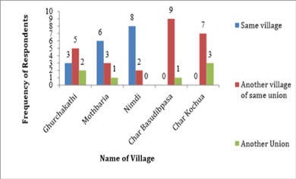

**4.1.3: Reasons for Displacements**

There were a lot of reason were but three of them were major. The reasons of displacement were the affected people were landless, they had nothing but low income, and had no place to live peacefully (Eva, Hazra, ET). For river bank erosion people displaced from one to another:

**Table 4.1.3: Graphical Representation of the Distribution of respondents according to their reason for migration**

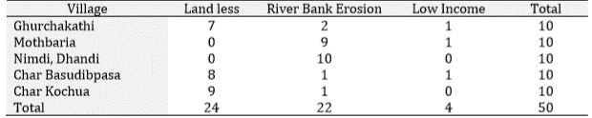

**4.1.4: Pattern of Displacements**

According to pattern of displacement the respondents were categorized into two. In Figure 03, it is indicated that majority respondents displaced permanently (Eva, Hazra, and ET). Deshingkar defined seasonal migration as a temporary move from and followed by return to the normal place of residence, for purposes of employment (Eva, Hazra, and ET).

**Figure 4.1.4: Graphical Representation of the Distribution of the respondents according to their pattern of displacement.**

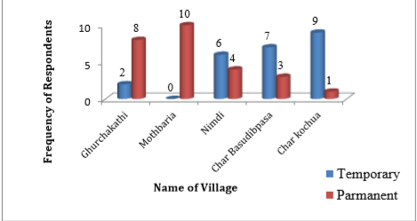

**4.1.5: Name of Homestead Shifting**

Displacement at family level is high. Disseminating dwelling structures and reconstructing at different sites require enormous effort, both in terms of money and manpower (Eva, Hazra ET). Migrated of the following Figure 04 indicated that the worsened situation at the site, where people had no option but to accept displacement as something fated. The number of homestead shifting, the respondents was classified into five categories as shown in the Figure 4.1.5.

**Figure 4.1.5: Graphical Representation of the Distribution of the Respondents to their Pattern of Homestead Shifting.**

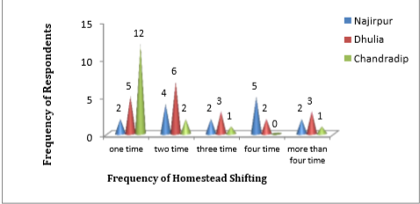

**4.1.6: Socio Economic Characteristic**

A closer look at the socio-economic condition of the people is relevant to understand clearly their perception and process of adjustment to erosion hazard (Eva, Hazra ET). Information collected at the field level and presented here in discussing the general characteristics are on age, sex, literacy, occupational status and changes, health facilities, status of settlement frequency of homestead shifting, choices of areas of further displacement, agriculture practice, cropping pattern and on certain related aspects of population dynamics (Eva, Hazra ET).

**4.1.7: Ownership of the Newly Emerged Land**

The figure below indicated that the contractor on an average occupy about 70% of newly land, Only the displaced respondents’ captures 18% of their eroded land and erosion affected families occupy 12% of the emerge land (Eva, Hazra, Et). The contract or control over the land through violence (Eva, Hazra, ET).

**Figure 4.1.7: Graphical Representation of Distribution of Respondents According to Ownership of Newly Emerging Land.**

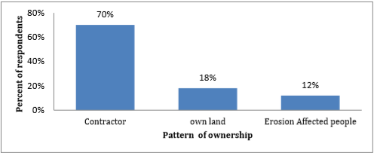

**4.1.8: Occupation**

This table indicates that respondents living in char area are mostly involved in fishing. Few of the respondents practiced agriculture, successful cultivation requires fertilizer recommendation (Sultana et al., 2015) Due to limited scope of employments (off-farming economic sector), the livelihood diversification in the study areas has become one of the major challenges (Hossain and Roy, 2010).

**Table 4.1.8: Tabular Representation of the Occupational Structure of the Respondents of the Study Area**

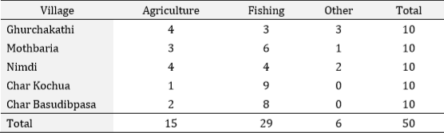

**4.2 Discussion**

**4.2.1: Riverbank Erosion in the Study Area**

Sirajgonj is a riverine area. Jamuna River is flowing along Sirajgonj district. River bank erosion is the common hazard in Sirajgonj district (Rabbi ET Saifullah). Every year many parts of the riverbank under Sirajgonj district are eroded by river (Rabbi ET Saifullah)

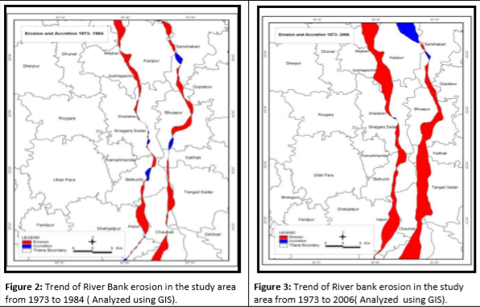

**Figure 4.2.1.1: Trend of River Bank Erosion from 1973-2006**

The comparative scenario can be drawn from 2 maps of figure 4.2.1 and from there it was observed that more erosion prone area was located in Kajipur, Sirajgonj Sadar, Shahjadpur and Belkuchiupzilla of Sirajgonj district. Maijbari area in Kajipurupzilla and Subhagachha were found more erosion prone than the other areas. Shailabari in Sirajgonj Sadar and Kaijuri in Shahjadpur also showed severe erosion. It was also revealed that erosion was followed by accretion though the rate was very low (fig.2). In the map 2 and 3 of figure 4.2.1, red color indicated the bank erosion and blue color indicated the accretion in the study area. It was evident from the comparative image that the trend of erosion projected increment and river bank erosion in 2006 was sequentially much more than that of 1973.

**Figure 4.2.1.2: Graphical Presentation of Erosion since 2000-2009**

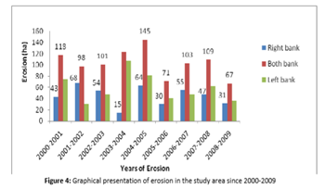

The figure 4.2.1.2 revealed that since 2000, the highest amount of land was eroded by the river in year 2001-2002, when 68 ha of land were eroded. Erosion seemed low in 2005-2006 sessions when 30 ha of land were eroded along the right bank of the river. A total of 118ha, 98ha, 101ha,123ha, 145ha, 71ha, 41ha, 103ha and 67 ha of land were eroded both bank of the Jamuna river by the year 2000-2001, 2001-2002, 2002-2003, 2003-2004, 2004-2005, 2005-2006, 2006-2007, 2007-2008 and 2008-2009 respectively.

**4.2.2: Riverbank Erosion in Study Area: Gorai Bank**

The focus is on the area on the bank line of Gorai within the Pourashava; in addition to this some very adjacent areas of Kumarkhali Pourashava Elongi, Elongi Acharya and Baruria of Nandalalpur union and Agrakunda of Sadaki union are considered (Figures 4.3.1, 4.3.2)

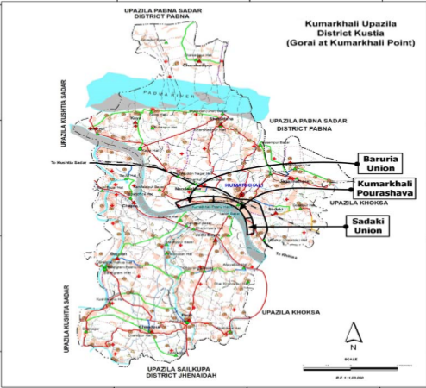

**Figure 4.2.2.1: Gorai at Kumarkhali point (At present)**

It is a map of Gorai Nodi with facing disaster riverbank erosion for being located in a geographic area where you still be created in a manner where the random village affected in the critic. So in this stated above map, the creation of the rising eye was so evident and distinctive that so many people were displacing from this place to another. Because there was a time where the respondent people are being marriage status and everything connected.

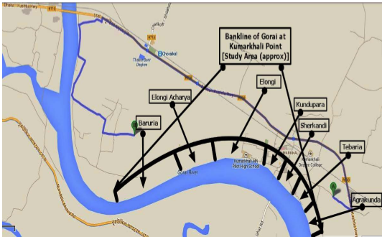

**Figure 4.2.2.2: Bank line of various study area at Kumarkhali point.**

**4.2.3: Characteristic of the Respondent**

**4.2.3.1: Age and Martial Status**

Among the respondent’s number of respondents aged below 30 years is only 5% and number of respondents aged above 70years+ is only 9%. Highest number of respondents (31) is between 51-60 years followed by 25 persons of age between 61-70 years (Table4.1)

**Table 4.2.3.1.1: Tabular Representation of the Age of the Respondent**

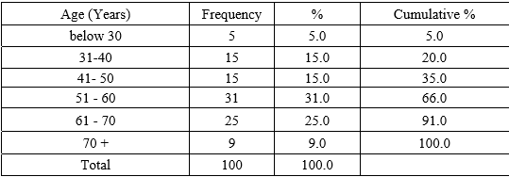

**Table 4.2.3.1.2: Tabular Representation of the Martial Status of the Respondent**

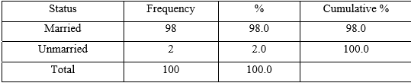

**4.2.3.2: Education Level of Respondent**

About half (45%) of the respondents are illiterate and slightly more than half (55%) of the respondents are literate. 15% respondents have 11-16 year of schooling (Baki 2014). Among the respondents about half of the total respondents (Table-3.4) are from Kumarkhali municipality (Baki 2014). Maximum of those who have 11-16 year of schooling belongs to Kumarkhali town. Large areas of Tebaria and Agrakunda are still like village though the areas belong to Pourashava (Baki 2014). In those areas education level of the respondents is not as high as Kundupara and Sherkandi (Baki 2014). Most of the illiterate people belong to the villages and village like areas of Tebaria and Agrakunda (Baki 2014).

**Table 4.2.3.2: Tabular Representation of the Education level of Respondent**

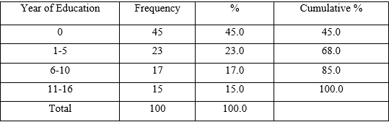

**4.2.4: Gorai Erosion Experience**

The impacts of riverbank erosion are long lasting and very often long term. According to Khalequzzaman (1994) the socio-economic impact and dislocation due to bank erosion are mostly permanent and most often long term.

In the study area Gorai river erosion is not a recent phenomenon. The local people have been experiencing this for the last hundred years (Baki 2014). Almost all the people on the bank line of Gorai have experienced erosion (Baki 2014). Directly victims are less in number as many of them have passed away (Baki 2014). But their family members who were indirectly victims have witnessed erosion very closely (Baki 2014). Among the respondents thirty-six percent are directly victims and sixty-four have witnessed it closely (table-4.7). Among two directly victims there are two heads of two educational institutes.

**Table 4.2.4.1: Tabular Representation of the Gorai Riverbank Erosion Experience (Source field survey 2014)**

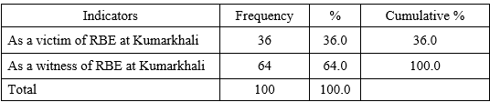

**Table 4.2.4.2: Tabular Representation of the Victims of Gorai RBE. (Source field Survey 2014)**

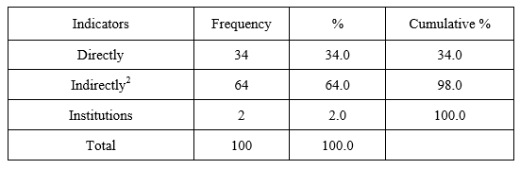

**4.2.5: Losses of Livelihood during River Bank Erosion**

During river bank erosion a lot of people lose their accommodation, their shelter, their places to live, their job, school, everything were under the water. The lives of the victims were miserable. River erosion seriously affects the livelihood of the affected people. Being affected many people become asset less, homeless, landless, in a word poor overnight (Baki 2014). They lose homestead, house, cultivable lands, kitchen garden/ home yard land and many other properties (Baki 2014). In the study area it is found that 83% has lost their homestead and houses, 90% their cultivable lands and 20% kitchen garden/ home yard land. One person has lost his loom factory in the 90s and his investment in the factory was tk. 15 lacs.

**Table 4.2.5: Tabular Representation of the Losses of the Livelihood during 1950-1999**

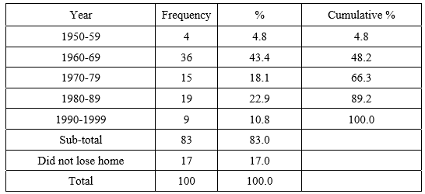

**4.2.6: Bitter Experiences of Gorai Victims**

Victims of Gorai riverbank erosion have gathered severe bitter experience due to erosion. Financial ability has decreased, compelled to change professions and got separated from their society. About 46% respondents have all the three experience. 5% respondents have both the experience of decreased financial ability and profession change. Individually the number of financial ability decreased displacers is the highest, 71%. On the other hand, the number of people compelled to change profession is 69%. The number of two types of victims is almost same.

**4.2.6.1: Struggles of Gorai Victims**

The erosion induced displacers fight against erosion in many ways. They try their level best to protect their homesteads, cultivable lands and essential household materials. Nothing is the exception in case of erosion induced victims of Kumarkhali. Table-4.15 shows that 56% victims have taken protective measures against erosion. 44% did not take any measure.

**4.2.6.2: Loss of Cultivate Lands**

Agricultural land is the main resource of Bangladeshi people. Almost 48% of the total population lives on agriculture (BBS, 2011). So the loss of cultivable land causes heavy impact on people dependent on agriculture (Baki 2014). In the study area we see that out of 100 respondents 90 respondents have lost their cultivable lands. Among the 90 respondents 28.9 % have lost their cultivable lands below 100 decimals (Baki 2014). 17.8% have lost lands in between 300 t0 400 decimals, 28.9% have lost their lands more than 400 decimals (Baki 2014). 24.4% respondents (22 out of 90) have lost lands worth below 3 lacs (Baki 2014). Second highest is 14.4% who have lost lands worth more than 17 lacs and 61.1% have lost their lands worth in between taka 3 lacs to 17 lacs.

**Table 4.2.6.2: Tabular Representation of the Amount of Cultivate Lands Loss.**

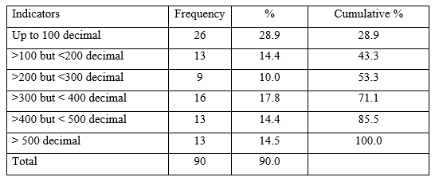

**4.2.6.3: Other Losses**

The loss of land is accompanied by a loss of infrastructure such as flood embankments, schools, hospitals, cultural and religious monuments and, of course agricultural lands and assets (Khalequzzaman, n.d.). In case of the study area we see that besides homestead, cultivable land and kitchen garden/yard land two educational institutes- Kumarkhali M. N. Pilot High School and Kumarkhali Degree College, two roads namely KumarkhaliTebaria-Agrakunda and Kumarkhali- Baruria, are also destroyed to the Gorai due to erosion. A handloom factory ‘Masud Textile’ is also destroyed in the Gorai river (Information provided by the owner at the time of questionnaire survey.

**4.2.7: Degradation of Quality of Life**

A lot of victims of Gorai bank has proclaimed that their life has become miserable after the erosion. Even after displacement people need to recover their status to become economically sustained but it takes a lot patience and time to established again. Some victims claimed they had everything and now they are living a very low quality life. it is seen that 84% respondents have said that their family has become hardcore poor, very poor or poor due to the impact of erosion. It is because, maximum respondents’ family is agriculture-based; due to erosion their only source of income is hampered. Only 9% have admitted that their family status has not been changed but financial ability has decreased. Among the 9% respondents who have said that their family status has not been changed, are urban dwellers. Professionally they are service holders.

They have admitted though their family status is not changed but financial ability has reduced. So it is clear almost all the erosion induced displaces have gone through degradation of quality of life. Local people informed erosion beside the river has been intensified in villages Knoagram, Morabila, Sona Kandor, Jamsapur and Bangarbah under Narua union of the upazila. Large cracks have been formed in many places and those huge chunks of land are being collapsed into the river.During the starting of the rainy season, people tried to check erosion by making bamboo fences along the river but failed to check it. Huge landed properties with houses and roads eroded into the river. Sohel Rana, resident of Narua village informed, erosion of the river has been intensified with the decrease of water of the river.

The erosion was also intensified along riverside while the water of the river was increasing. People living beside the river are worried at the intensity of the erosion. So it has been told that people have a lot of occupation and losses in the sphere of the system that recognize the depth of the Pacific Ocean with the need of the river.

**Table 4.2.7.1: Tabular Representation of the Miserable status of Gorai Victims.**

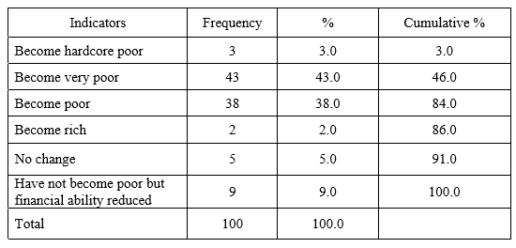

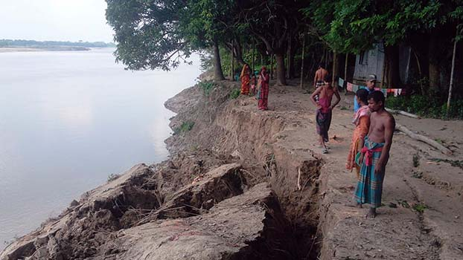

**Figure 4.2.7.2: Shows the miserable scenario of Gorai Bank Erosion**

**4.2.8: Respondents’ Perceptions on the Reasons of Gorai RBE**

Facing erosion induced vulnerability the respondents have conceived their own perceptions about riverbank erosion. According to 25% of the respondents the reason of Gorai riverbank erosion at Kumarkhali is Weak planned construction of groins; 18% thinks that it is because of blocking of Dakua and Kaliganga River due to GK Project. A large portion of respondents (15%) think that Farrakka Barrage is responsible for this.

**4.2.9: Present Situation of Gorai RBE Scenario**

Embankment has been constructed from Kundupara to Baruria. Erosion is under control. In this regard question may come whether people are relieved. Table-4.36 shows that 41% people are still in fear. Maximum of the people on the bank at Tebaria, Agrakunda are afraid of erosion. Also large number of people of Elongi, Elongi Acharya and Baruria has the fear in mind as the embankment is not repaired or constructed every year on the basis of emergency.

Riverbank erosion is a disastrous calamity; especially for Bangladesh where there are about 700 rivers, and many areas on the bank line are erosion prone. Every year somewhere some people are experiencing erosion and going through miserable vulnerabilities. Sometimes this suffering continues generation after generation because of the lack of proper measures to control erosion as we see in Kumarkhali.

**4.3 Recommendation**

Over the result and discussion, we’ve find a lot of loopholes and mistakes. If we can work on those mistakes, then we might create great prevention methods and center for the victims and others. The previous section demonstrates that the inhabitants of erosion prone areas live in environments where the level of risk is very high. In these conditions, migration is a response to actual or anticipated risk. However, the higher the risk, the stronger is the pressure to migrate. This section focuses on actions that can be taken to reduce the level of risk faced by individuals, and therefore make the migration process more voluntary. One of the main challenges of working in erosion prone areas is the frequent migration of the affected individuals. Bebbington & Farrington (1993) argue that mobility is a challenge in itself for development initiatives, which often have a significant local focus. It is indeed difficult to provide durable services or build infrastructure in a context where the land can disappear due to erosion and where the turnover of the beneficiaries is very high due to migration. Therefore, it is necessary to rethink the ways in which services are delivered in these areas and make them more flexible and adapted to the needs of people at risk. Addressing problems of communication in erosion prone areas should not be limited to simply building roads. Rather, more attention should be paid to the improvement and accessibility of boat services, especially during periods of hazard.

The construction of infrastructure (such as schools, clinics, houses, etc.) should not be halted or discontinued due to the risk of erosion. Instead they should be designed in such a way that makes them easy to dismantle and transport to another location if necessary. The same kind of innovation should be explored in the way services are delivered. Services should be provided in a mobile and flexible way to cater to the needs of affected populations. National NGOs such as Friendship have floating hospitals (on boats) as well as river ambulances (equipped speed boats). The NGO also offers a service of satellite clinics where medical teams visit several chars once a month by boat to provide basic healthcare. The idea of floating markets near chars and erosion prone areas may also be explored, which would facilitate the buying and selling of goods without having to travel to the mainland.

In order to cope with the material losses incurred by hazards, insurance systems for the poor may be set up through collective savings groups. Shelter for crops, animals, and valuable belongings are also needed. In addition, putting in place a more efficient system of land management and land allocation would help towards reducing conflicts and ensuring more equitable access to the land. It is important to make the communities a part of the decision-making process as much as possible. The communities know their area better, are better able to identify their needs, and know the limits of what is possible to achieve. Better access to information and good governance will help to limit corruption and collusion of local authorities with local elites, thus contributing to improvement of justice for these communities.

**Chapter 5: Conclusion**

**5.0 Conclusion**

In conclusion we can say that riverbank erosion stays as a persistent danger to the riparian occupants and the land-scant nation. Consistently, an enormous number of its populace is uprooted due the riverbank disintegration. They misfortune their property and relocate to somewhere else to make new settlement. These ecological displaced people become helpless in general in each sense. Prior to breaking down circumstance to out of hand, the opportunity has already come and gone to make fundamental moves to stop intense dislodging and occupation the board of the people in question. In this study erosion was found in gradual projection in the examined region and went about as a push factor for relocation. Individuals were found uprooted because of this natural phenomenon. The effect of erosion on the regular asset and financial state of the dislodged populace was multilateral. In one side it was taking out the estates and foundation, harming harvests of the individuals, in general expanding destitution. Then again endemic riverbank erosion was quietly causing poverty on the grounds that it denied the erosion influenced families from their ordinary responsibilities to make due in any event for a specific timeframe. Its high time Government should take measure steps to prevent further land loss due to riverbank erosion.

**References**

ADB [Asian Development Bank], 2010. Padma Multipurpose Bridge Project: Environmental Assessment Report. Project Number: 35049. Asian Development Bank. Dhaka, Bangladesh. Online: www.adb.org/sites/default/files/project-document/63200/35049-01-ban-eia.pdf (accessed 20 July 2017).

Ahmed N., 1989. Study of some bank protective works in Bangladesh. Department of water resource engineering, BUET, Dhaka.

Alam M.S., Hoque N., 1998. Channel pattern and sedimentation style in the Meghna River, Bangladesh: An example of a large-scale anastomosing fluvial system. Journal of remote sensing and environment 2.

Anas, A., 2019. Bangladesh’S Disappearing River Lands. [Online] The New Humanitarian. Available at: < <https://www.thenewhumanitarian.org/Bangladesh-river-erosion-engulfs-homes-climate-change-migration> > [Accessed 2 January 2021].

Azuma R., Sekiguchi H., Ono T., 2007. Studies of High-resolution Morphodynamics with Special Reference to River Bank Erosion vol. 50(C). Annuals of Disaster Prevention Research Institute. Kyoto University, Japan.

Baki, A., 2020. Socio-economic impacts of gorai riverbank erosion on people: a case study of kumarkhali, kushtia. [Online] Dspace.bracu.ac.bd. Available at:

<<http://dspace.bracu.ac.bd/bitstream/handle/10361/3532/13372004.pdf?sequence=1>> [Accessed 24 December 2020].

Bangladeshpost.net. (n.d.) Balaikandi people in panic for Gorai river erosion. [Online].Retrieved from: <https://bangladeshpost.net/posts/baliakandi-people-in-panic-for-gorai-river-erosion-17121>

BWDB [Bangladesh Water Development Board], 2013. Water discharge data. Bangladesh Water Development Board. Govt. of Bangladesh, Dhaka.

CEGIS [Center for Environmental and Geographic Information Services], 2003. Ganges River: Morphological Evolution and Predictions. Prepared for Water Resources Planning Organization (WARPO). Dhaka.

CEGIS [Center for Environmental and Geographic Information Services], 2005. Prediction for Bank Erosion and Morphological Changes of the Jamuna and Padma River. Dhaka.

CEGIS [Center for Environmental and Geographic Information Services], 2010. Long-term Erosion Process of the Padma River. Prepared for Jamuna-Meghna River Erosion Mitigation Project. Bangladesh Water Development Board. Dhaka.

Chowdhury, M., 2020. *Meghna River*. [Online] En.wikipedia.org. Available at: < <https://en.wikipedia.org/wiki/Meghna_River> > [Accessed 2 January 2021].

Chowdhury M.H., 2003. Padma River. In: Banglapedia the National Encyclopedia of Bangladesh. Bangladesh Asiatic Society. Dhaka.

Clijncke, A., 2001. Morphological response to dredging of the upper Gorai River.

Dewan A., Corner R., Saleem A., Rahman M.M., Haider M.R., Rahman M.M., Sarker M.H., 2016. Assessing channel changes of the Ganges–Padma River system in Bangladesh using Landsat and hydrological data. Geomorphology 276: 257–279. DOI.

Deb, B., 2021. *Dhaka Tribune | Jamalpur News Update In Bangladesh, World | Page-1*. [online] Dhakatribune.com. Available at: < <https://www.dhakatribune.com/hashtag/jamalpur/> > [Accessed 2 January 2021].

Dhaka Tribune. (2020). River Erosion takes serious turn in northern districts. [Online] Retrieved from: <https://www.dhakatribune.com/bangladesh/nation/2020/07/08/river-erosion-takes-serious-turn-in-northern-districts>

Earthobservatory.nasa.gov. 2021. *World Of Change: Padma River*. [Online] Available at: < <https://earthobservatory.nasa.gov/world-of-change/PadmaRiver> > [Accessed 2 January 2021].

Haque C.E., 1985. Impact of River Bank Erosion in Kazipur: An Application of Landsat Imagery. Workshop of the Impact of River Bank Erosion and Flood Hazards in Bangladesh, Dhaka.

Hasnatay, A.S.M, Saifullah, Sheikh, S, ET. Al. *Recent Study on River Bank Erosion and Its Impacts on Land Displaced People in Sirajgonj Riverine Area of Bangladesh.* Retrieved from: <https://drive.google.com/file/d/1S8JmFORzItSaeBUTa1RcT5yN8WYlgcs4/view>

Hassan S., Akhtaruzzaman A.F.M., 2010. Environmental Change Detection of the Padma River in the North-Western part of Bangladesh using Multi-date Landsat Data. Proc. of International Conference on Environmental Aspects of Bangladesh (ICEAB10), Japan.

Hassan M.S., Mahmud-ul-Islam S., 2016. Quantification of River Bank Erosion and Bar Deposition in Chowhali Upazila, Sirajganj District of Bangladesh: A Remote Sensing Study. Journal of Geoscience and Environment Protection 4(1): 50–57. DOI.

Hossain Bhuiyan, M., Islam, S. and Azam, G., 2021. *Exploring Impacts And Livelihood Vulnerability Of Riverbank Erosion Hazard Among Rural Household Along The River Padma Of Bangladesh*. [Online] Springer Link. Available at: <

<https://link.springer.com/article/10.1186/s40068-017-0102-9> > [Accessed 2 January 2021].

Mallick, B. & Etzold, B. *Environment, Migration and Adaptation Evidence and Politics of Climate Change in Bangladesh.* Retrieved from:

<https://drive.google.com/file/d/1XMJ9NoQQFTQtxyM3UG3VXtBvpvjb0_bN/view>

Mallick, A. & Parvin, M. (2019), *Risk Informed early warning system and non-migration pattern riverbank erosion areas.* Retrieved from:

<https://www.preventionweb.net/files/67631_67631rivererosionearlywarningreport.pdf>

Nazneen Aktar, M. (2013). Impacts of Climate Change on River Bank Erosion. *International Journal of Sciences: Basic and Applied Research (IJSBAR). International journal of Sciences: Basic and Applied Research*, [online] 7(1), pp. 36-72. Available at: <https://core.ac.uk/download/pdf/249333559.pdf>

Islam, M. F. and Rashid, A.N.M. B. 2011, *Riverbank erosion displaces in Bangladesh: Need for institutional response and policy intervention*. Bangladesh Journal of Bioethics,2(2); P4-19

Islam and Islam, 1985; Cited in Hutton, D. and Haque, C. E. 2004, *Human Vulnerability, Dislocation and Resettlement: Adaptation Processes of River-bank Erosion –induced Displacees in Bangladesh*, Disasters, 2004, 28(1): 41-62Joint River Commission

Bangladesh, Ministry of Water Resources, The People’sRepublic of Bangladesh, Retrieved February 2014 from the Joint River CommissionBangladesh website: <http://www.jrcb.gov.bd/basin_map.html>

Islam, D., 2021. *Bank Erosion of the River Meghna: Population Displacement and Socioeconomic Impacts*. [Online] Academia.edu. Available at: <

<https://www.academia.edu/514467/Bank_erosion_of_the_river_Meghna_Population_displacement_and_socioeconomic_> > [Accessed 2 January 2021].

Iva, T.T, Hazra, P, ET. Al. *River bank erosion and its impact on population displacement in Bauphal upazila under Patuakhali district, Bangladesh.* Retrived from: <https://drive.google.com/file/d/1VWWfScVeG4DgsmzLtM2Fe9wEkyLnvt_A/view>

Iva, T., Hazra, P., Faisal, M., Saha, S. and Hossain, S., 2017. River bank erosion and its impact on population displacement in Bauphal upazila under Patuakhali district, Bangladesh. *Journal of Science Technology and Environment Informatics*, [online] 5(2), pp.371-381. Available at: <https://www.journalbinet.com/uploads/2/1/0/0/21005390/39_jstei_river_bank_erosion_and_its_impact_on_population_displacement_in_bauphal_upazila_under_patuakhali_district_bangladesh_.pdf> [Accessed 23 December 2020].

Khalequzzaman, M 1994, Recent *floods in Bangladesh: possible causes and solutions,* natural hazards9:65-80, 1994

Rahman, M.R. *Impact of Riverbank Erosion Hazard in The Jamuna Floodplain Areas in Bangladesh.* Retrieved from:

<https://drive.google.com/file/d/1N1FbgsCW5Tk7gqGcY4s3TLxCIw0SHb2v/view>

*River bank erosion could be curbed by forecast.* (2015, April 2). The Daily Star. Retrieved from: <https://www.thedailystar.net/city/river-bank-erosion-could-be-curbed-forecasts-75106>

*River bank erosion and human displacement in Bangladesh*. (n.d.). Daily Sun. Retrieved from: <https://www.daily-sun.com/arcprint/details/336349/River-bank-erosion-and-human-displacementin-Bangladesh/2018-09-16>

Sawpan, S., 2019. *Meghna River Erosion: People In Lakshmipur At Risk As Dam Awaits Completion*. [Online] Dhaka Tribune. Available at: <

<https://www.dhakatribune.com/bangladesh/nation/2019/07/14/meghna-river-erosion-people-in-lakshmipur-at-risk-as-dam-awaits-completion> > [Accessed 2 January 2021].

Shikto, A. and Nisha, N., 2021. *ADPC*. [Online] Adpc.net. Available at: < <https://www.adpc.net/igo/contents/iPrepare/iprepare-news_id.asp?ipid=176> > [Accessed 2 January 2021].

Wiggering, H., Johnson, A., Costanza, R., Kienast, F. and Cheng, S., 2021. *Living Reviews In Landscape Research*. [Online] Lrlr.landscapeonline.de. Available at: < <http://lrlr.landscapeonline.de/> > [Accessed 2 January 2021].